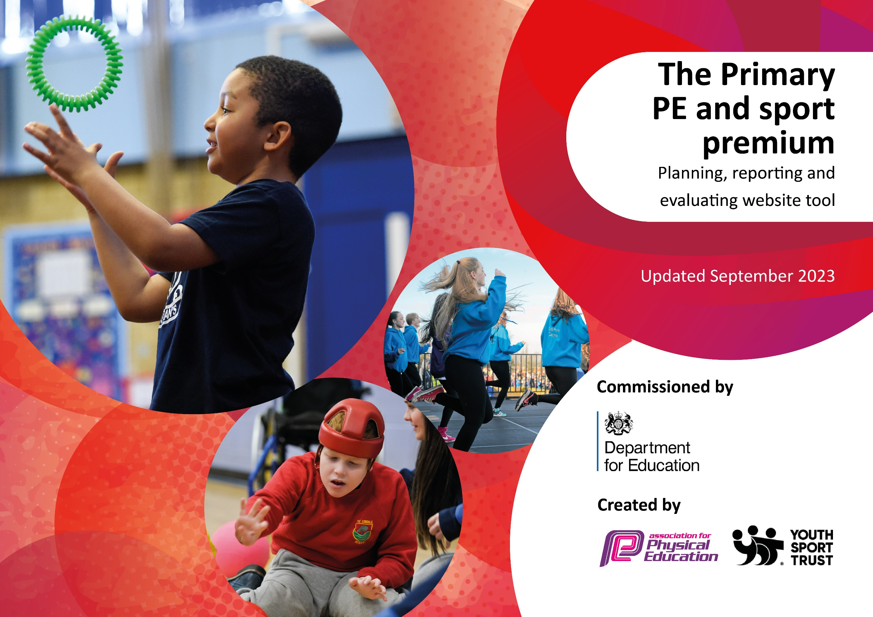

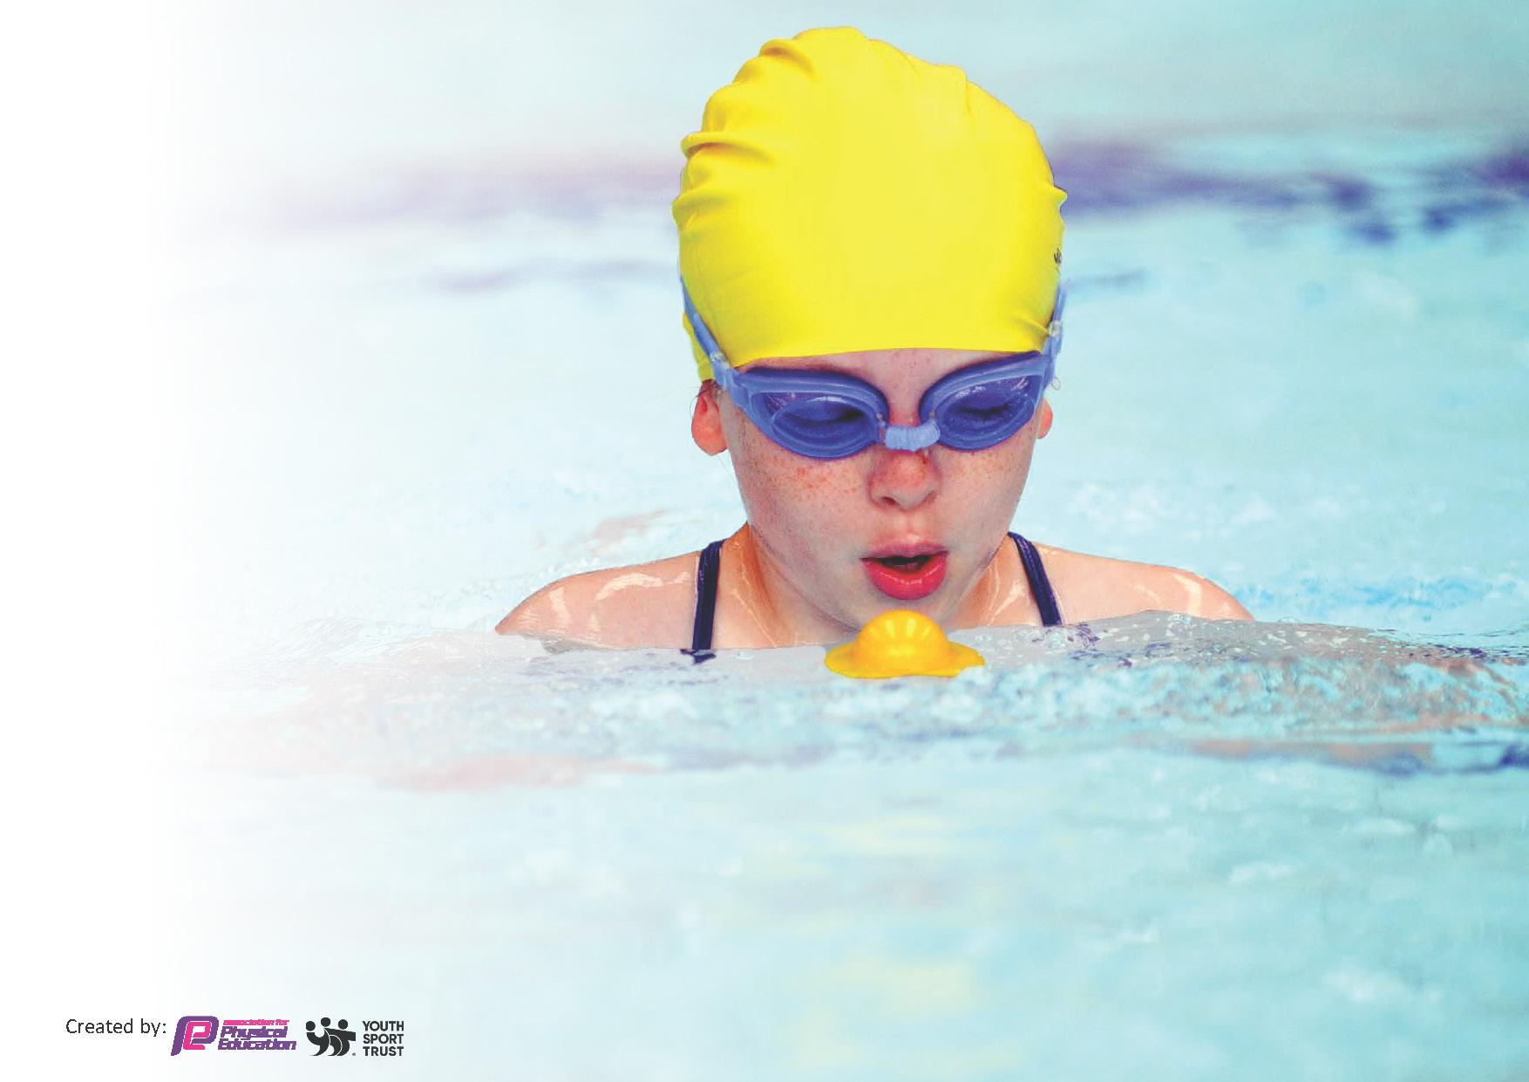
This template can be used for multiple purposes:
by:
- It enables schools to effectively plan their use of the Primary PE and sport premium
- It helps schools to meet the requirements (as set out in guidance) to publish information on their Primary PE and sport premium
- It will be an effective document to support Ofsted inspections enabling schools to evidence progress in Physical Education (PE) and evidence swimming attainment, which forms part of the PE National Curriculum. We would recommend schools consider
the Intent, Implementation and Impact of any spend, as examined within the Education Inspection Framework.

It is important that your grant is used effectively and based on school need.

Schools must use the funding to make additional and sustainable
improvements to the quality of the PE, School Sport and Physical Activity (PESSPA)
they offer. This means that you should use the Primary PE and sport premium to:

- Build capacity and capability within the school to ensure that improvements made now will benefit pupils joining the school in future years
- Develop or add to the PESSPA activities that your school already offers.

The Primary PE and sport premium should not be used to fund capital spend projects; the school’s core budget should fund these. Further detail on capital expenditure can be found in the updated Primary PE and sport premium guidance.

The Primary PE and sport premium guidance, outlines 5 key priorities that funding should be used towards. It is not

necessary that spending has to meet all the key priorities, you should select the priorities that you aim to use any funding towards.

Although completing this template is not a requirement for schools, schools are required to publish details of how they spend this funding. Schools must also outline what the impact this funding has had on pupils’ PE and sport participation and attainment and how any spending will be sustainable in the future. All funding must be spent by 31st July 2024.

The Department for Education has worked closely with the Association for Physical Education (afPE) and the Youth Sport Trust (YST) to develop this template and encourages schools to use it. This template is an effective way of meeting the reporting requirements of the Primary PE and sport premium.
Review of last year’s spend and key achievements (2022/2023)

We recommend you start by reflecting on the impact of current provision and reviewing your previous spend.

Activity/Action | Impact | Comments
Training midday staff and giving them specific roles to encourage physical activity for all children.  Additional swimming lessons for those who have not met the criteria.  Build an area of provision whereby children can be physically active and develop their physical and teamwork skills. | There has been an increase in participation and supervision in physical activity during lunchtimes.  Additional swimming lessons have allowed for the majority of children to meet the minimum swimming standards.  This area is offered to the children on a daily basis and allows children to explore physical activity whilst using their imaginations; the construction zone also builds teamwork skills and communication. | The children now have more direction from an experienced adult and a wide variety of equipment to enhance and channel their physical activities.  All children in year 6 have passed their swimming assessment for the academic year 23-24.  This area has allowed children to explore their physical abilities through creative construction and imaginative exploration.

Key priorities and Planning
This planning template will allow schools to accurately plan their spending.

Action – what are you planning to do | Who does this action impact? | Key indicator to meet | Impacts and how sustainability will be achieved? | Cost linked to the action
- Use FGS to support teaching PE within school. Use FGS to provide weekly provision within school (Monday & Wednesday) teaching a variety of areas of PE and additionally provide children with an opportunity to experience different sporting activities. Lunchtime clubs to be offered as part of the FGS package.  - Take part in more inter-school competitions via the Rushcliffe SSP.  - PE funding will be used to purchase sporting equipment.  - Additional PE-based activities to be on offer.  - Additional PE-based activities to be on offer.  - School Sports day trophy to be purchased. | - Teaching staff are positively impacted as they are learning and being offered continuous professional development from a specialist coach;  children are being taught by a sport specialist PE coach.  - The children will benefit from the range of sporting events offered by Rushcliffe SSP.  This allows teaching staff to develop further connections with other schools and share best practice.  - Having specialised equipment will allow for children to be able to take part in activities with the correct equipment. We will be able to better facilitate their learning.  - Specialist Basketball Coach- ‘Jimmy Jumpshot’ will come to school and deliver specialised lessons to year 4,5,6 children. The children also are able to enter into a basketball ‘Mini-leaders competition’.  - Naomi offers yoga for the children in school from Yr R to Yr 6. She will be able to offer share ways to encourage a positive mental attitude. Year 6 chn also have support to manage their mental health/anxiety before the national assessments.  - This action will impact all children taking part in the annual sports day, which has now changed to involve a more competitive element to previous years. | - Key Indicator 1- The teaching staff work alongside the FGS coach and develop their own knowledge and CPD.  Key indicator 2- The sports coach from FGS offers lunchtime clubs in areas that differ from the mainstream sports (eg boxing.) This encourages children to be more physically active and gain skills in a new area of PE.  - Key indicator 1- SSP allows for the PE coordinator to develop their knowledge and understanding of physical education. This is then able to be passed on to the wider teaching staff.  Key indicator 4 and 5- Rushcliffe SSP offers a range of sporting activities that expose children to new/a wider range of sporting opportunities such as pace ball.  - Key indicator 4- having the equipment accessible for the children means they have a more meaningful interaction with different sports.  - Key Indicator 5- children will be put into the Mini – leader tournament whereby they play other schools in a competitive environment.  Key Indicator 2- children are offered more time to participate in physical activity.  - Key indicator 2- Naomi has come in annually and encourages the children to partake in yoga. She adapts her teaching style to suit all ages.  Key indicator 3- this sport is used throughout the whole school as a method of wellbeing and mental health improvement.  Key Indicator 4- children are exposed to a wider variety of sporting activities.  - Key Indicator 3- the profile of Sports day will be increased and it allows for children to get a better understanding of different athletic events and it also adds an element of competition.  Key indicator 5- children will compete in houses to win the Sports day Trophy. | - Staff are continually developing their own understanding and can therefore give high quality lessons.  - The links formed by the different schools will continue to develop.  - This equipment will be used for pe, sporting events and playtimes for future events.  - The skills that the children learn will be transferrable to other sports they will encounter throughout the PE curriculum. Important skills will be reinforced.  - The skills taught to the children, are ones they are able to use whenever needed (with or without direction). The instructor gives the children tools to help with daily problems/anxieties they may face.  - This will be a symbol each year for the children to work collaboratively in their houses (supporting the school values). | - £12949.98 is the cost of FGS in for 2 full days per week for the academic year.  - £750.00 for CPD and sporting events.  - The sporting equipment was purchased from County Supplies for £87.37.  - Invoice to Jimmy Jumpshot will be £490.00  - Invoice to Naomi for yoga will be £240.00.  - School will be charged £20.99.

Key achievements 2023-2024
This template will be completed at the end of the academic year and will showcase the key achievements schools have made with their Primary PE and sport premium spending.

Activity/Action | Impact | Comments
Employing First Grade Sport.  Continuing with the Rushcliffe Sports Partnership.  Using a specialist Basketball coach.  Whole school yoga day.  New trophy for whole school sporting event. | Children have received quality specialist coaching and been allowed the opportunities to learn different sports. The PE coach has also support extra-curricular events and run additional lunchtimes sporting clubs ensuring children are being more physically active. Staff CPD has also been further developed.  This opportunity has allowed for the children to experience more and a wider variety of sports.  The sporting opportunities available have ranged from ball sports, such as Paceball, to Orienteering and Kayaking; a wider range of skills have been developed. The PE coordinator has also been able to meet and advance their CPD by going to meetings run by the RCC sporting partnership.  The children love this opportunity and have a better understanding of basketball. It has also increased competitive spirit.  The whole school were able to enjoy and learn different wellbeing techniques from Naomi. The children were able to take away coping mechanisms for stress and relaxation. She makes the days enjoyable for all of the children.  The purchase of the trophy was a great tool for supporting a competitive element between the ‘houses’. The children enjoyed the added element of competition. | First Grade has supported the school greatly. Moving forward, more PE CPD will be implemented to ensure a secure knowledge of the PE curriculum and updated ways to teach PE. I will also organise more sporting opportunities for as a whole school initiative.  Utilising the partnership has had many benefits to the PE curriculum at Kinoulton. Continuing to use them will advance the sporting opportunities at the school for all year groups.  This is an annual event and will continue in to 24-25 to encourage a love for the sport but also to allow for specialist coaching to occur.  Having yoga as a wellbeing day for the children has been a great opportunity.  It is an important element of the curriculum for the children to have these mental wellbeing opportunities.  We will continue to use the trophy annually for sports day.

Swimming Data
Meeting National Curriculum requirements for swimming and water safety.
Priority should always be given to ensuring that pupils can perform safe self-rescue even if they do not fully meet the first two requirements of the National Curriculum programme of study

Question | Stats: | Further context  Relative to local challenges
What percentage of your current Year 6 cohort can swim competently, confidently and proficiently over a distance of at least 25 metres? | 100%
What percentage of your current Year 6 cohort can use a range of strokes effectively [for example, front crawl, backstroke, and breaststroke]? | 100%

What percentage of your current Year 6 cohort are able to perform safe self-rescue in different water-based situations? | 100% | Use this text box to give further context behind the percentage.
If your schools swimming data is below national expectation, you can choose to use the Primary PE and sport premium to provide additional top-up sessions for those pupils that did not meet National Curriculum  requirements after the completion of core lessons. Have you done this? | Yes/No | We used the schools budget to pay for additional swimming lessons due to a high percentage of children who did not pass the previous year. We feel that swimming is an important skill to have and we wanted to ensure that all children meet the minimum requirement for swimming outlined in the NC.
Have you provided CPD to improve the knowledge and confidence of staff to be able to teach swimming and water safety? | Yes/No

Signed off by:

Head Teacher: | Simon Paramore
Subject Leader or the individual responsible for the Primary PE and sport premium: | Rachel Dean
Governor: | (Name and Role)
Date: | July 2024

