# Subtraction

**Year 1 Year 2 Year 3**

**- = signs and missing numbers**

7 - 3 = = 7 - 3

7 - = 4 4 = - 3

- 3 = 4 4 = 7 -

- ∇ = 4 4 = - ∇

* Understand subtraction as 'take away'



7-2 = 5 There are 5 ladybirds left

* Find a 'difference'



11 – 7 = 4 The difference between 11 and 7 is 4

Find the difference by counting up. I have saved 5p. The socks that I want to buy cost 11p. How much more do I need in order to buy the socks?



* Use practical and informal written methods to support the subtraction of a one-digit number from a one digit or two-digit number and a multiple of 10 from a two-digit

number.

I have 11 toy cars. There are 5 cars too many to fit in the garage. How many cars fit in the garage?



Use the vocabulary related to addition and subtraction and symbols to describe and record addition and subtraction number sentences

Recording by

- drawing jumps on prepared lines

- constructing own lines

**- = signs and missing numbers**

Continue using a range of equations as in Year 1 but with appropriate numbers.

Extend to 14 + 5 = 20 -

## Find a small difference by counting up

42 – 39 = 3



## **Subtract 9 or 11. Begin to add/subtract 19 or 21**

35 – 9 = 26



**Use known number facts and place value to subtract**

Subtract 20 from 36.

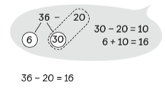 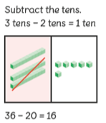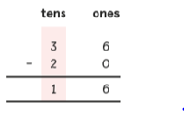

Towards written methods

Recording addition and subtraction in expanded columns can support understanding of the quantity aspect of place value and prepare for efficient written methods with larger numbers. The numbers may be represented with Dienes apparatus. E.g. 75 – 42

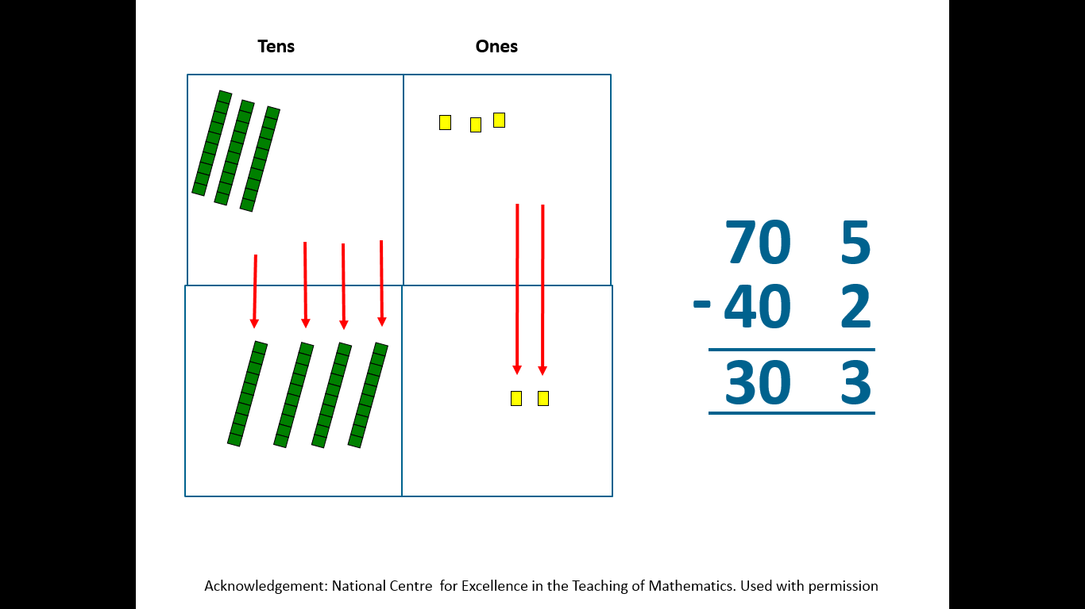 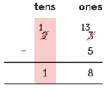

Moving to subtract

with renaming.

**- = signs and missing numbers**

Continue using a range of equations as in Year 1 and 2 but with appropriate numbers.

**Find a small difference by counting up**

Continue as in Year 2 but with appropriate numbers e.g. 102 – 97 = 5

**Subtract mentally a ‘near multiple of 10’ to or from a two-digit number**

Continue as in Year 2 but with appropriate numbers e.g. 78 – 49 is the same as 78 – 50 + 1

**Use known number facts and place value to subtract**

Continue as in Year 2 but with appropriate numbers.

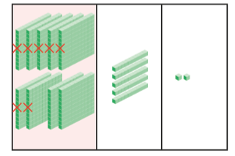 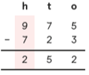

And regroup 100 into 10’s

Regroup one 10 into 1’s

Subtract the 1’s

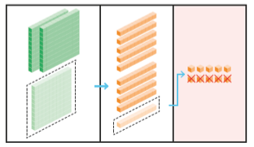 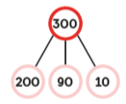 

## Pencil and paper procedures

Complementary additio



Column subtraction with renaming. 