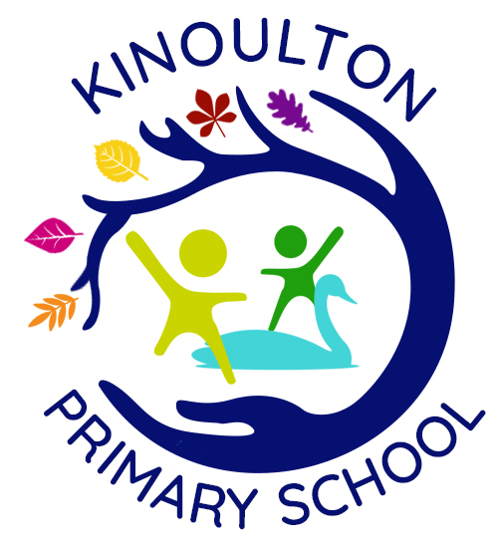

**READING POLICY**

**July 2021**

**Abigail Huntingford**

**Review Date – July 2025**

**Reading Policy KPS**

Intent:

**Knowledge-rich**

* All children are about to articulate and reason about the world around them through a highly developed vocabulary
* Children can understand and respond to what they read

**Purposeful**

* Children apply their reading skills to learn, develop and progress throughout school and beyond
* Children are fluent and responsive readers

**Stimulating**

* All children have a love of reading through exposure to high quality texts

Developing Readers at KPS

* Use a range of strategies to enable children to read accurately and fluently
* Help children to understand and respond to what they read using inference and deduction where appropriate
* Allow children the opportunity to reflect on and discuss what they have read, including language and punctuation choices made by the author
* Expose children to a variety of text types including fiction, non-fiction and poetry
* Encourage children to develop a love of reading whilst becoming confident, fluent and independent readers
* Teach children how to seek information and learn from written texts
* Use drama and role-play (where appropriate) to engage and immerse children in a text
* Teach children how to articulate their opinions and ideas about a text
* Teach them a breadth of cross-curricular knowledge through reading
* Making home-school links to share reading strategies and support ongoing reading outside of school

Phonics

Phonics is predominantly taught in Key Stage 1 through the Monster Phonics scheme. All members of staff (teaching and teaching assistants) have undertaken the Monster Phonics training.

Lessons take place daily in Key Stage 1. Children are streamed into 3 groups.

Children who do not pass the Key Stage 1 Phonics Screening assessment are required to repeat the assessment in year 2. Prior to this, their phonics knowledge will have been accelerated through use of intervention.

Any children who are still unable to pass their Phonics Screening Assessment, will also receive catch-up phonics in Key Stage 2. This will be delivered via the use of Lexia and/or short, intensive phonics interventions.

Reading Books

In Key Stage 1, children are matched to colour-coded reading books depending on their phonic ability. Books are changed once weekly, unless parents request a more regular book change.

In addition to this, Key Stage 1 have access to Bug Club in which children can access their banded reading books at home. This programme gives children appropriate questions to answer about what they have read. This is an optional extra to allow parents to feel supported when reading with their child at home by giving them insight into the types of questions and conversations they can be having around their child’s reading.

When starting in Key Stage 2, each child is matched to their reading level from teacher assessments. Some children may use KS1 phonetically decodable books if necessary.

Key Stage 2 books have been colour coded by challenge; starting at yellow spot and moving through to white spot.

Children are encouraged to also take a non-fiction book alongside their fiction reading book.

In Key Stage 2, children are encouraged to take more responsibility for their reading and are encouraged to change their reading books as and when they need to.

In addition to reading books, Key Stage 2 children take part in regular ‘Poetry Challenges’ in which they are encouraged to learn a variety of key poetry off by heart.

In Key Stage 1, the bottom 20% of children are heard reading their reading books by an adult in school once weekly.

Teachers across school, monitor home-school reading diaries once weekly to ensure that children are being heard reading 5x weekly.

For children who aren’t meeting this expectation, a reminder of expectations is written in the diary by the class teacher.

Reading at home is encouraged through the your of the ‘Star Reader’s’ system. Children who read to an adult at home 5x per week earn points.

When children have read:

5 weeks of ‘full reading’ they achieve their bronze award.

12 weeks of ‘full reading’ they achieve their silver award.

20 weeks of ‘full reading’ they achieve their gold award – their name goes onto the gold list which can be found on the Reading Stars display.

30 weeks of ‘full reading’ they achieve their platinum award – their photo goes on the Reading Stars display and they receive a Reading Stars Badge. There is a new coloured badge to be collected each academic year.

Guided Reading

Guided reading lessons are delivered in a whole class format and take place 2x weekly across the school.

Texts selected are age-appropriate and will offer challenge to all readers. A variety of texts will be chosen, varying between fiction, non-fiction and poetry. Where appropriate, film units may also be used. Texts are matched to a current area of learning – English genres, history, geography, science etc. Texts may be accessed through the iPads.

Guided reading lessons will follow the VIPERS format; questioning and tasks will be planned around these reading skills.

* Vocabulary
* Inference
* Prediction
* Explanation
* Retrieval
* Sequence (KS1)/ Summarise (KS2)

Children will be explicitly taught each of these reading skills and will be made aware of which skills they are required to call upon to complete a task.

Alongside the above, reading will be taught explicitly during these lessons, using a range of age/ability appropriate strategies. E.g. choral reading, ‘I read, you read,’ individuals reading to the class, independent reading etc.

Children in Class 1 have ‘Super 6’ books which are read to them throughout the term. The class teacher asks appropriate VIPERS style questions throughout these lessons in order to assess children’s understanding. Please see ‘Super 6’ planning for further details.

Reading Comprehension

Reading comprehension lessons take place weekly across the school. Comprehension texts will relate to current areas of learning – English genre/topic related texts.

Questioning and tasks follow the VIPERS format and will allow children to build on prior or current learning, strengthening and deepening knowledge and understanding.

Class Story

Each class will have story time several times weekly, in which the teacher reads the children a story.

Stories are not expected to relate to any in school learning and can be chosen by the class or the class teacher.

These sessions are purely to encourage children to read for enjoyment.

Working With Parents/Carers

Reading Friday gives parents/carers for the children to come into school and read with their children. This takes place from 9am – 9:30am weekly. Children are encourage to sit with their adult and read their reading books. It models good reading behaviours and allows children a set time to share reading with their adults and peers. Any children who don’t have an adult sit with the class teacher/teaching assistants and read to them.

In order to support phonics learning at home, we deliver an annual Phonics Workshop for parents to attend. The content includes: information about what phonics is, the terminology used, the programme used in school, and supporting phonics and reading at home.

A Fluent Readers workshop is delivered **biannually** for parents of children in KS2. This offers parents advice of how to support and encourage already fluent readers.

Assessment

Reading is assessed regularly through the use of summative assessment using PM Benchmarking. Early reading is assessed through phonics assessments.

SEND

Any children with special needs will be identified and work within their individual level. Where needed, these children will have scaffolds, additional resources and differentiated tasks and texts and where possible, will work with support under the direction of the class teacher.

See SEND policy for further details.