**KINOULTON PRIMARY SCHOOL**

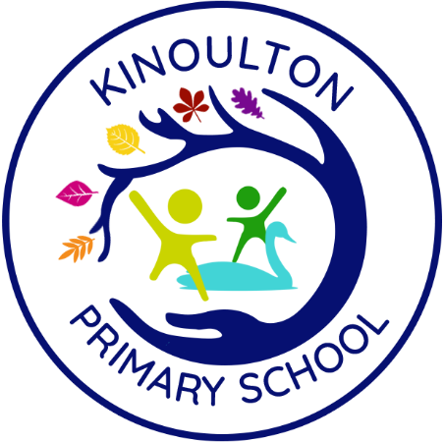

**PSHE POLICY**

**Including:**

**Relationships Education, Health Education and Relationships and Sex Education**

**September 2024**

**Simon Paramore**

**Review Date – July 2025**

# Kinoulton Primary School – PSHE Aims

We aim to promote high standards of progress and achievement and for our pupils to:

* Develop enquiring minds and enthusiasm for learning
* Become responsible, independent and active citizens
* Lead a healthy lifestyle
* Be able to work and play co-operatively
* Respect themselves, others and the environment
* Be happy and confident

**Context**

All schools must provide a curriculum that is broadly based, balanced and meets the needs of all pupils. Under section 78 of the Education Act 2002 and the Academies Act 2010, a PSHE curriculum:

* Promotes the spiritual, moral, cultural, mental and physical development of pupils at the school and of society, and
* Prepares pupils at the school for the opportunities, responsibilities and experiences of later life.

This policy has been written with regard to the Department for Education’s guidance ‘Relationships Education, Relationships and Sex Education (RSE) and Health Education’ published in June 2019.  This is statutory guidance issued under section 80A of the Education Act 2002 and section 403 of the Education Act 1996.  These regulations are made under sections 34 and 35 of the Children and Social Work Act 2017 and provide that pupils receiving primary education must be taught Relationships Education and Health Education.  The policy is also influenced by a number of other statutory legislation and non-statutory guidance including the Equality Act 2010 and Keeping Children Safe in Education.

PSHE helps to give pupils the knowledge, skills and understanding they need to lead confident, healthy, independent lives and to become informed, active, responsible citizens. At Kinoulton Primary School, we teach Personal, Social, Health and Economic (PSHE) education as a whole-school approach to underpin children’s development as people and because we believe that this also supports their learning capacity.

The Jigsaw Programme offers us a comprehensive, carefully thought-through Scheme of Work which brings consistency and progression to our children’s learning in this vital curriculum area.

The overview of the programme can be seen within this policy. Jigsaw also supports the “Personal Development” and “Behaviour and Attitude” aspects required under the Ofsted Inspection Framework, as well as significantly contributing to the school’s Safeguarding and Equality Duties, the Government’s British Values agenda and the SMSC (Spiritual, Moral, Social, Cultural) development opportunities provided for our children.

The Jigsaw Programme is aligned to the PSHE Association Programmes of Study for PSHE.

**How we teach PHSE at Kinoulton Primary School**

A whole-school approach is effective because pupils’ personal and social development is influenced by many aspects of school life.

Although PHSE/Citizenship should pervade everything that happens in school there are certain times that allow for a more structured focus:

* Assembly Time

Assemblies provide an opportunity to enhance pupils’ spiritual, moral, social and cultural development. Time can be spent identifying, promoting and celebrating the school’s values. In addition to this, we deliver assemblies which prepare children for life in modern Britain, considering British values: mutual respect, tolerance, democracy, individual liberty, rule of law. Assemblies also respond to the needs of the children in the context of our school; we aim to provide children with a wider understanding of a range of cultures and current affairs, for example.

#### PSHE in the Weekly Timetable

PSHE lessons take place weekly and they are planned and delivered with the support of the Jigsaw materials. Details about the Jigsaw programme are included in this policy. We deliver PSHE lessons in year groups to ensure that the material is age-appropriate.

###### Provision through PSHE activities and school events

###### At Kinoulton Primary School, there are many opportunities for pupils to work together and to develop their relationships within the whole school community, local community and wider community including:

* Residential visits for KS2 pupils
* Educational visits to support the curriculum
* Special days/weeks on health
* Visits from the school nurse
* School induction week each September
* Fundraising for charities and to promote thinking of others
* Taking part in assemblies
* Helping in other classes e.g. reading swaps between older/younger classes
* Class/community projects (e.g. litter picking in the community, Story Telling Projects with schools from EQT)
* Awards/certificates for appropriate behaviour/attitudes given in Merit assemblies.
* Discussing documents such as Human Rights Policy, Commission for Racial Equality, Equal Opportunities issues and other government literature such as healthy eating guides etc.
* Links with parents such through the PTFA (finance initiatives/fundraising)
* Sports links with various sporting bodies
* Visitors (particularly role models/inspirational speakers)
* Our extensive lunchtime club provision
* Pupils roles in school – pupils are given positions of responsibility (monitors, playground play leaders, councillors, JRSO etc)
* Relevant curriculum topics/activities such as ‘butterflies living kits’ and ‘living eggs’
* Harvest festival (proceeds donated to Emmanuel House)
* Outdoor learning culture
* An active school council that meets half termly to discuss issues raised by classmates
* An active RLA Pupil Parliament with representatives visiting County Hall once a term to discuss issues of county concern/interest
* Assemblies/activities to promote an understanding of how democracy works in Britain – particularly at times near to elections/referendums.
* Annual pupil interviews and surveys (summer)
* Buddy reading activities between our older and younger pupils promoted at certain times of the year
* Enrichment weeks/problem solving days
* Visits to a range of places of worship and associated relevant visitors.
* Reflection opportunities in assemblies
* Workshops at relevant times to support curricular studies. These have included Indian dance, African drumming and Chinese New Year celebrations
* Weekly MFL teaching (including insights into culture) for our KS2 pupils.
* RE – KPS follows the locally agreed syllabus including the study of all major faiths
* Weekly ‘Reading Friday’ in KS1, inviting family members into school
* Inviting members of the local community to experience ‘previews’ performances (Nativity, Shakespeare)

**Content Covered through Jigsaw**

The following pages detail the content covered in each unit of the Jigsaw programme. At Kinoulton, we will adapt the delivery of the content to take into account the children in the class and the context of the lesson. However, the content will remain the same.

**Overview of the Jigsaw Programme**

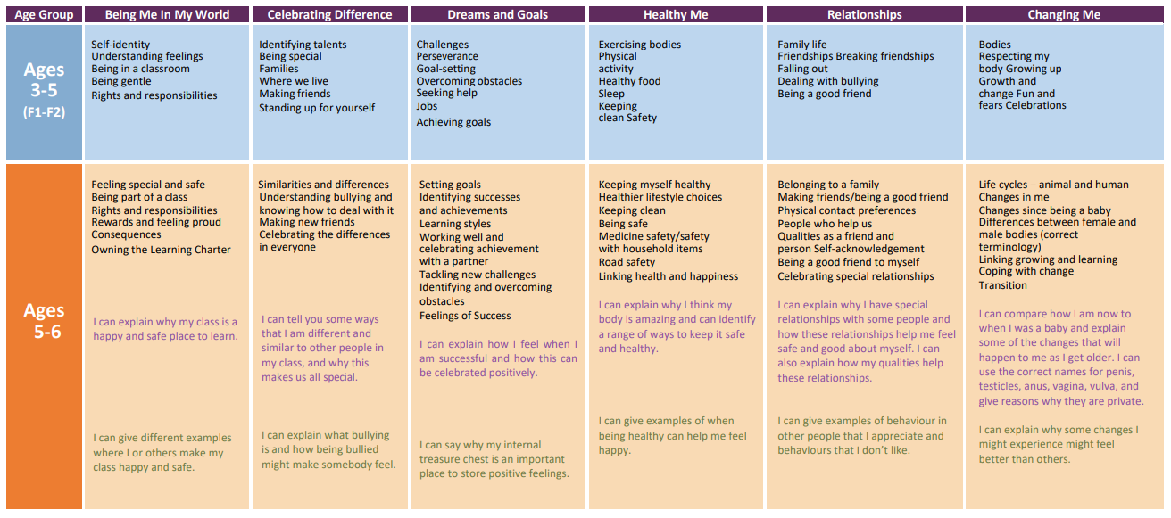

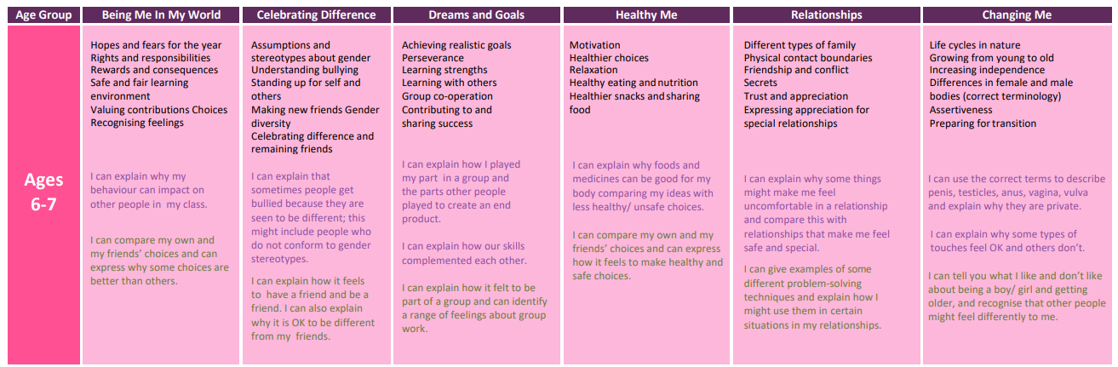

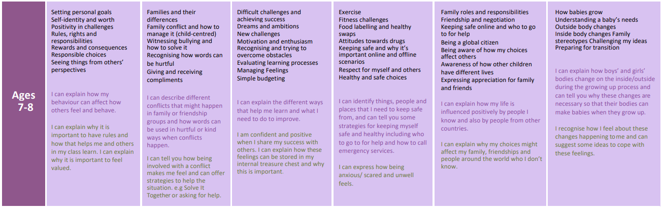

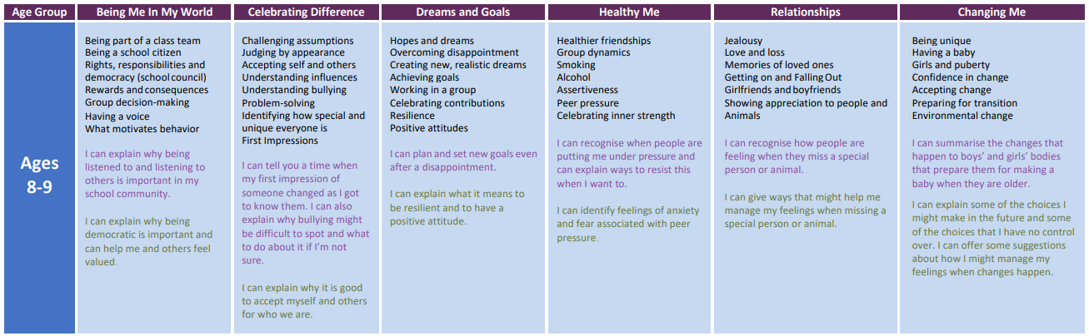

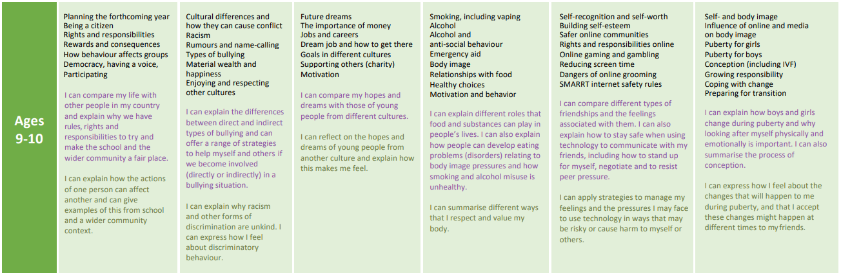

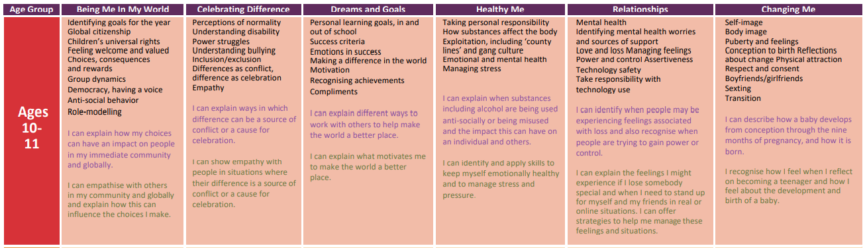

**Relationships and Sex Education**

At Kinoulton Primary School, we believe that our provision of sex education throughout the whole school meets the developing needs our pupils.  The content of the sex education can be seen in more detail for each year group below.  In broad terms, it takes a balanced and factual approach exploring healthy relationships, consent, reproduction, pregnancy and child-birth in an age-appropriate manner.  Teachers will inform parents when they are planning to teach elements of SRE and will outline what aspects will be covered and what resources will be used.

Parents are able to withdraw their child from this part of the curriculum if they would prefer to deliver this element of the curriculum themselves and where it is not a compulsory part of the Science curriculum. The RSE element is optional at primary, although recommended by DFE.

“The Department continues to recommend...that all primary schools should have a sex education programme tailored to the age and the physical and emotional maturity of the pupils. It should ensure that both boys and girls are prepared for the changes that adolescence brings and – drawing on knowledge of the human life cycle set out in the national curriculum for science - how a baby is conceived and born.”

DFE RSHE Guidance 2019

**RSE – the right to withdraw**

In certain circumstances, parents / carers do have the right to withdraw their children from RSE (Relationships and Sex Education).

Parents will have the right to withdraw their child from sex education but not from statutory Relationships Education or Health Education. Following discussion with the school, parents can withdraw their child from the ‘sex’ elements of Relationships and Sex Education. Parents do not have a right to withdraw their child from Health education, Relationships or any other aspect of PSHE education.

There is no right of withdrawal from National Curriculum Science which includes elements of sex education such as puberty and reproduction.

If a parent/carer wishes to withdraw their child, they need to have a discussion with the Headteacher so that he can be made aware of the reasons and provide alternative arrangements. We will try to accommodate any concerns as far as possible.

**The RSE Curriculum at Kinoulton**

We deliver RSE through the Jigsaw programme (along with the rest of the PSHE curriculum). All of the RSE elements are covered in the final half term of each summer term during a whole school topic called ‘Changing Me’. The content that is delivered in this topic is detailed on the following pages.

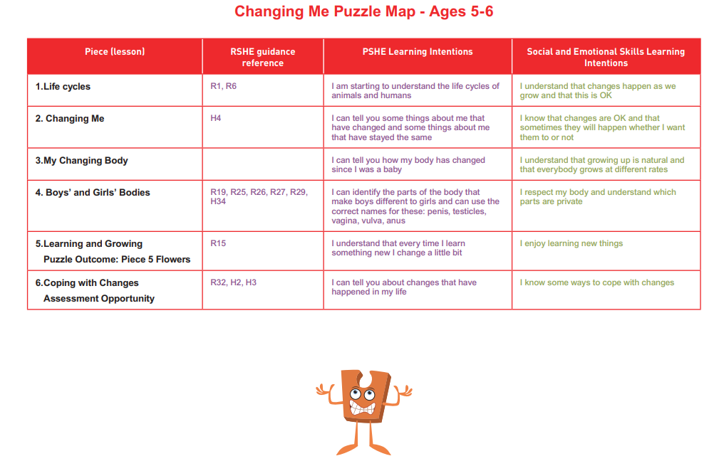

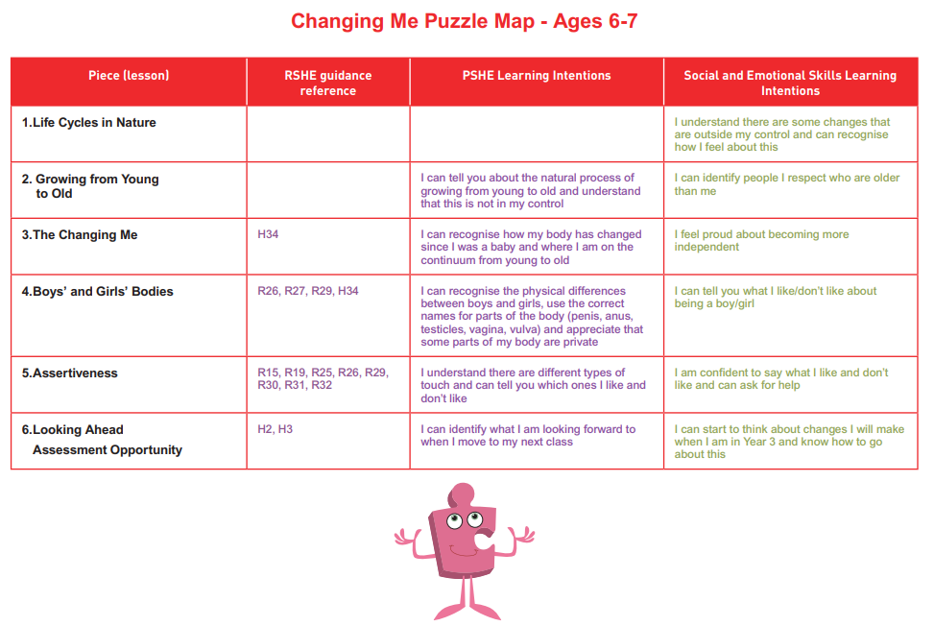

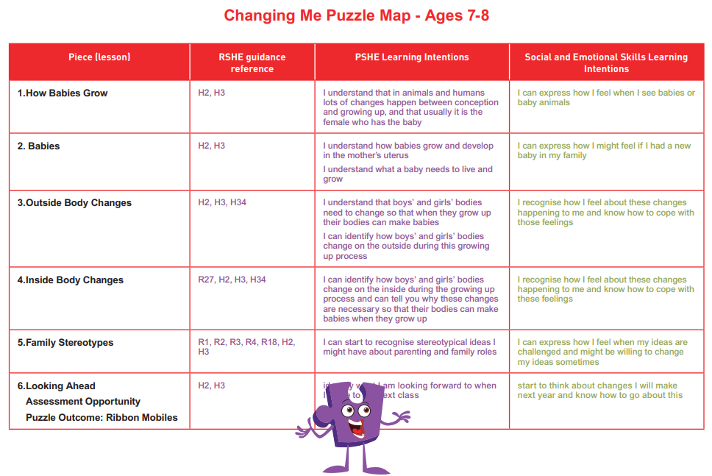

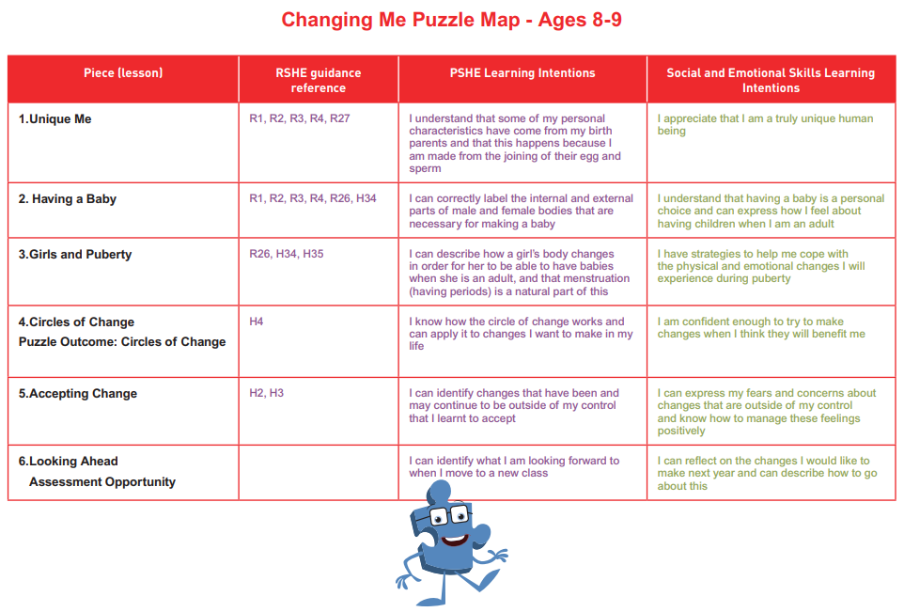

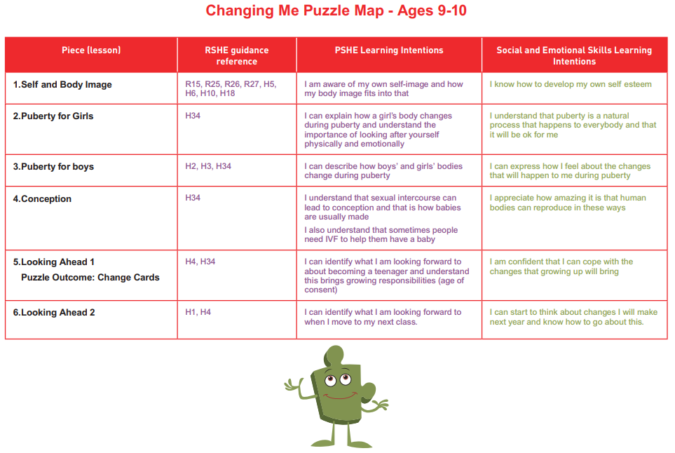

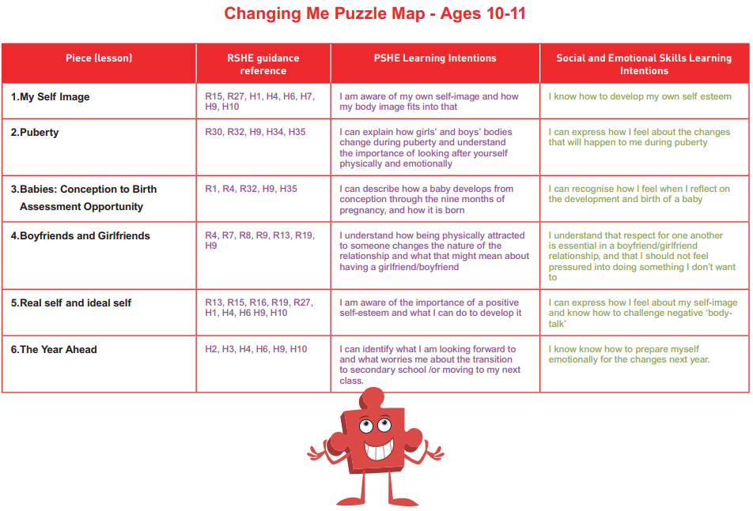

**Responding to Children’s Questions**

Questions asked by any pupil in the school on this subject will be answered sensitively and factually. During lessons on sex education children may ask questions about topics which are not specifically taught as part of a planned programme. Such topics might include contraception, sexually transmitted diseases, homosexuality, abortion, rape etc.

The teacher has to decide whether:

1. To answer the question right away.

1. To ask the child to wait for the answer until the class has been dismissed.

1. To contact the child’s parents.

1. To deal with the question in accordance with the school’s Child Protection Policy because there is a child protection issue.

As a general rule if the question is about something which is likely to be appropriate to and relevant for the majority of the class, then it should be answered honestly, openly and right away.

All staff, including teaching and support staff, may be asked questions relating to sexual matters. The adult should be clear about what the child wants to know and the reason why. This will give an indication of the child’s own level of understanding. If possible a simple, honest answer should be given but if a member of staff feels uncomfortable then the question should be referred to the head teacher and/or the child’s class teacher.

Staff should **NOT** promiseconfidentiality. If a childprotection issue came to light, it must be reported to the Designated Safeguarding Lead who would take the appropriate action.

**Dealing with pupils’ menstruation needs**

Parents are asked to inform school of anything that we need to know, in order to make the children’s experiences at school as comfortable as possible. This includes letting us know if their daughter has started to menstruate, so that we can give support should they require it.

As a matter of course, girls in Year 5 are given instruction about menstruation and as part of these sessions they are shown where and how to dispose of their used towels and who to ask to help, should they need it. A sanitary towel waste bin is located in the class 4/5 girls toilets.

**Inclusion**

RSHE and PSHE should be accessible for all pupils. As a school we promote inclusion for all and the celebration of difference. Every child and family have a right to feel included and valued at Kinoulton Primary School.

Under the Equality Act 2010 we have a duty not to discriminate against people on the basis of their age, disability, gender, gender identity, pregnancy or maternity, race, religion or belief and sexual orientation. The Act allows schools to take positive action to deal with particular disadvantages affecting one group because of one of the characteristics listed above. An example of this in relation to RSE and PSHE in our school is that we may need to provide additional learning opportunities for children with special educational needs and/or disabilities.

***Pupils with Special Educational Needs and Disabilities***

As with other subjects, pupil with SEND may need additional support to access the RSHE/PSHE curriculum. Teachers will assess the needs of each pupil and ensure that appropriate support is put in place. This may involve individual work with a TA and/or small group work. We will liaise with parents to ensure that each child’s needs are met where necessary. Some pupils, for example those with Autistic Spectrum Disorders, may need a more explicit approach to some of the key concepts of RSHE/PSHE. If this is the case, this will be discussed with parents/carers to ensure a plan is put in place to support learning both at school and at home. Appropriate resources will be provided if and where necessary.

***Diverse families***

In our provision of RSHE and PSHE we will explore the diverse families that are represented in our school and in wider society, including same sex parents, single parents, adopted families, fostering, children living with grandparents and so on. Our resources and teaching will reflect this diversity to ensure every pupil feels included and valued.

***Gender***

We actively challenge stereotypes around gender through RSHE, PSHE and our wider curriculum and the Kinoulton Primary School ethos. Our aim is for pupils to be respectful of all genders and recognise the equality of all.

**Assessment**

PSHE learning is assessed in a range of ways;

* Children’s understanding, knowledge and skills are assessed through discussions and questioning in lessons and may be noted onto the Jigsaw interactive summative assessment sheets by teaching staff.
* Each class has a child included in our weekly merit assemblies and their achievements are celebrated in front of their peers.
* Pupils may record some aspects of work in PSHE lessons on whole-class displays and flipcharts. The children are also regularly involved in self-assessment activities.
* Comments relevant to PSHE are included in the annual report to parents. The ‘general comments’ section often reflects their progress in PSHE.

**Safeguarding**

**Confidentiality & Child Protection**

Effective PSHE teaching and learning may bring about disclosures of child protection issues and staff should be aware of the procedures for reporting their concerns. The school has a separate Child Protection policy and the procedures outlined for Child Protection issues at Kinoulton Primary School should be followed. As a general rule a child’s confidentiality is maintained by the teacher or member of staff concerned. However, if this person believes the child to be at risk or in danger, the teacher will pass this concern on to the Designated Safeguarding Lead.

**Controversial and Sensitive Issues**

Staff are aware that views around some PSHE issues are varied. However, whilst personal views are respected, all PSHE issues are taught without bias. Topics are presented considering a variety of views and beliefs so that pupils are able to come to their own informed opinions but also respect others who may have a different view.