**Overview of the Jigsaw Programme**

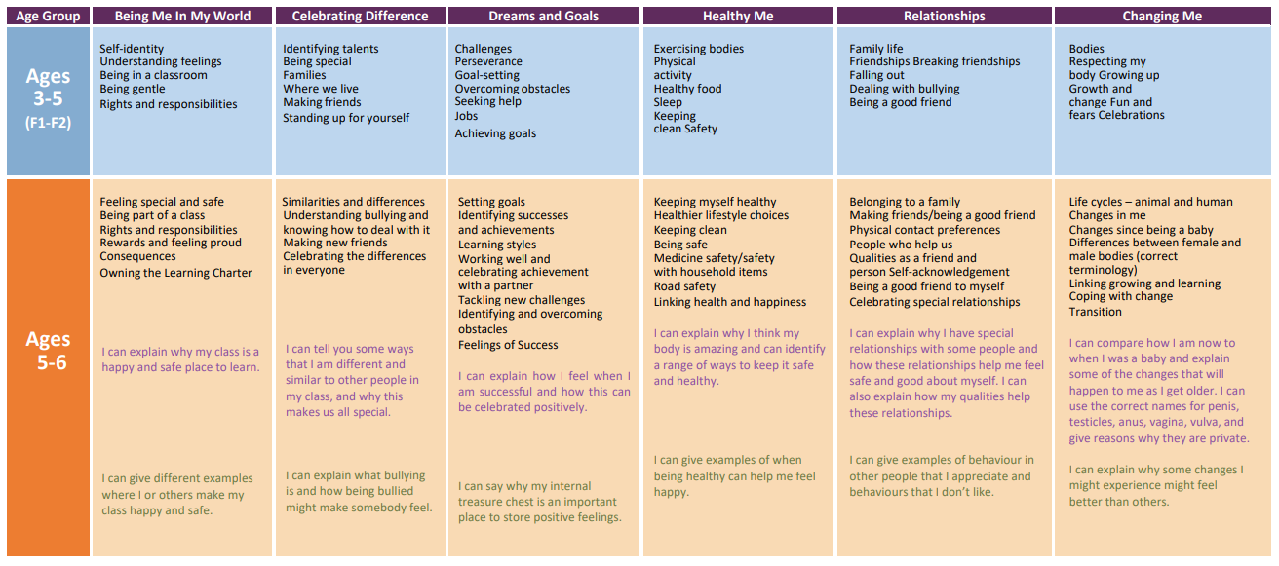

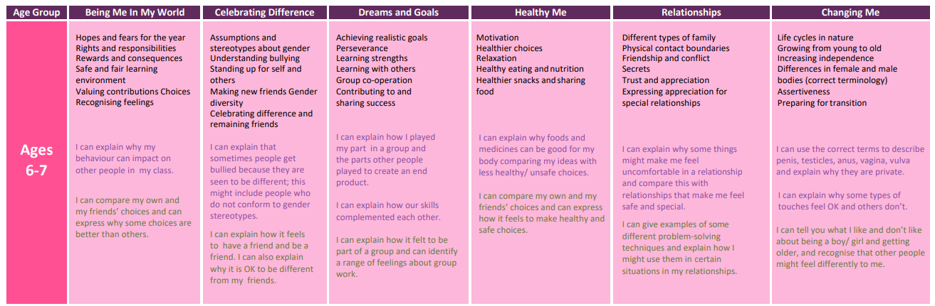

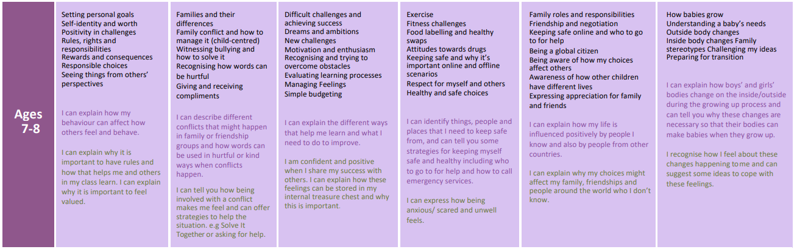

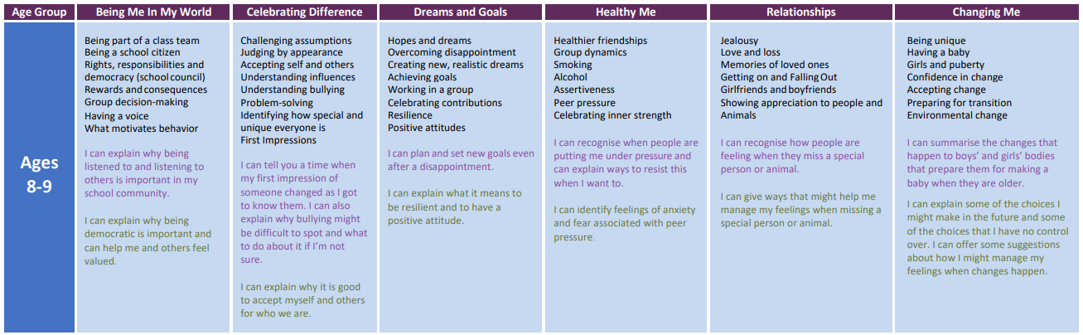

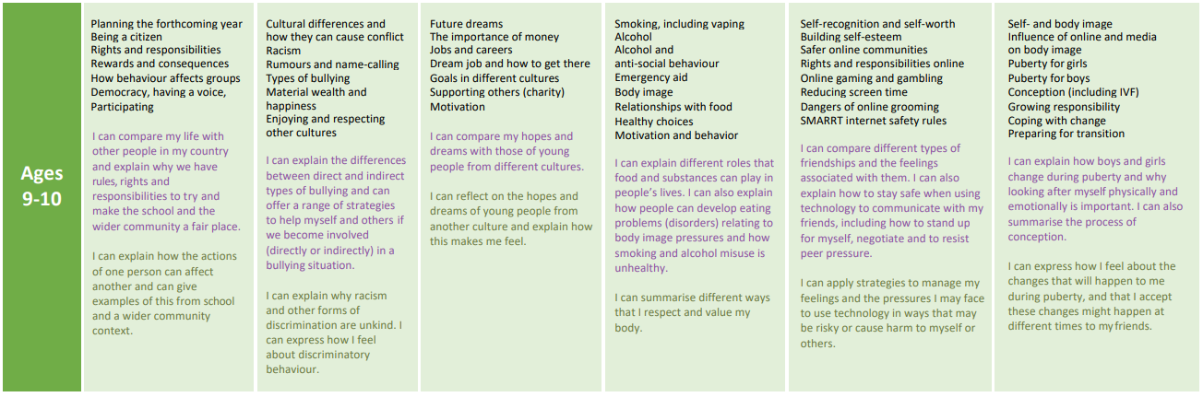

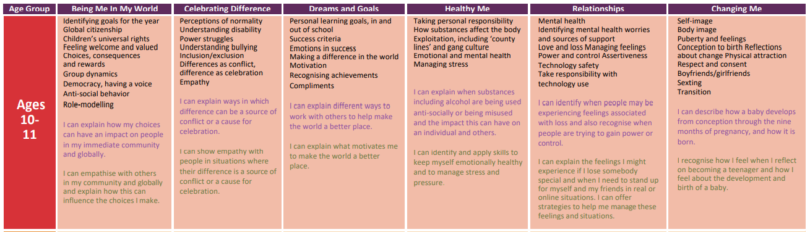

**Relationships and Sex Education**

At Kinoulton Primary School, we believe that our provision of sex education throughout the whole school meets the developing needs our pupils.  The content of the sex education can be seen in more detail for each year group below.  In broad terms, it takes a balanced and factual approach exploring healthy relationships, consent, reproduction, pregnancy and child-birth in an age-appropriate manner.  Teachers will inform parents when they are planning to teach elements of SRE and will outline what aspects will be covered and what resources will be used.

Parents are able to withdraw their child from this part of the curriculum if they would prefer to deliver this element of the curriculum themselves and where it is not a compulsory part of the Science curriculum. The RSE element is optional at primary, although recommended by DFE.

“The Department continues to recommend...that all primary schools should have a sex education programme tailored to the age and the physical and emotional maturity of the pupils. It should ensure that both boys and girls are prepared for the changes that adolescence brings and – drawing on knowledge of the human life cycle set out in the national curriculum for science - how a baby is conceived and born.”

DFE RSHE Guidance 2019

**RSE – the right to withdraw**

In certain circumstances, parents / carers do have the right to withdraw their children from RSE (Relationships and Sex Education).

Parents will have the right to withdraw their child from sex education but not from statutory Relationships Education or Health Education. Following discussion with the school, parents can withdraw their child from the ‘sex’ elements of Relationships and Sex Education. Parents do not have a right to withdraw their child from Health education, Relationships or any other aspect of PSHE education.

There is no right of withdrawal from National Curriculum Science which includes elements of sex education such as puberty and reproduction.

If a parent/carer wishes to withdraw their child, they need to have a discussion with the Headteacher so that he can be made aware of the reasons and provide alternative arrangements. We will try to accommodate any concerns as far as possible.

**The RSE Curriculum at Kinoulton**

We deliver RSE through the Jigsaw programme (along with the rest of the PSHE curriculum). All of the RSE elements are covered in the final half term of each summer term during a whole school topic called ‘Changing Me’. The content that is delivered in this topic is detailed on the following pages.

