x = signs and missing numbers
Continue using a range of equations as in Year 2 but with appropriate numbers

Partition
Continue to use arrays:

18 x 9 = 162

18 x 9 = (10 x 9) + (8 x 9) = 162

OR

Use the grid method of multiplication (as below)

Written methods

Grid method
23 x 7 is approximately 20 x 10 = 200

x 20 3
7 140 21 = 161

Short multiplication
2 digit numbers x 1 digit extending to 3 digit number x 1 digit number
23 x 7 = 161 123 x 7 = 761

2 3 1 2 3
x 7 x 7
1 6 1 7 6 1
2 2

2
x = signs and missing numbers
Continue using a range of equations as in Year 2 but with appropriate numbers

Partition
87 x 6 = 522

87 x 6 = (80 x 6) + (7 x 6) = 522

OR

Use the grid method of multiplication (as below)

Pencil and paper procedures
Grid method
372 x 24 is approximately 400 x 20 = 8000

Extend to multiplying 4 digit numbers x 2 digit numbers.
Extend to decimals with up to two decimal places.
Use efficient methods
Short multiplication
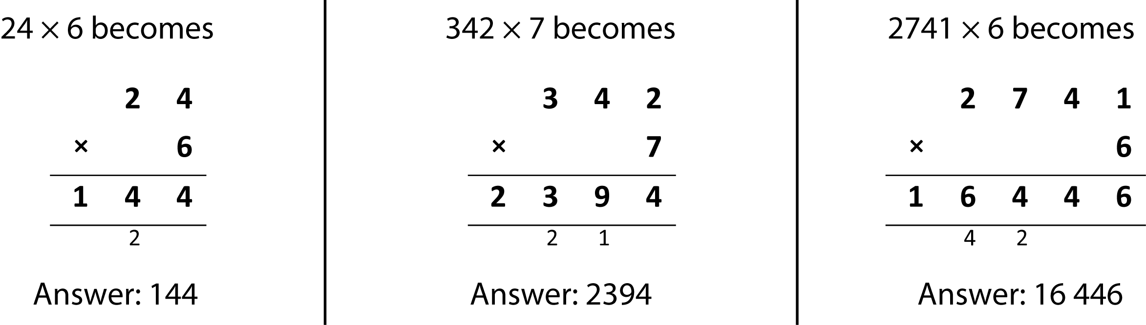
Long multiplication
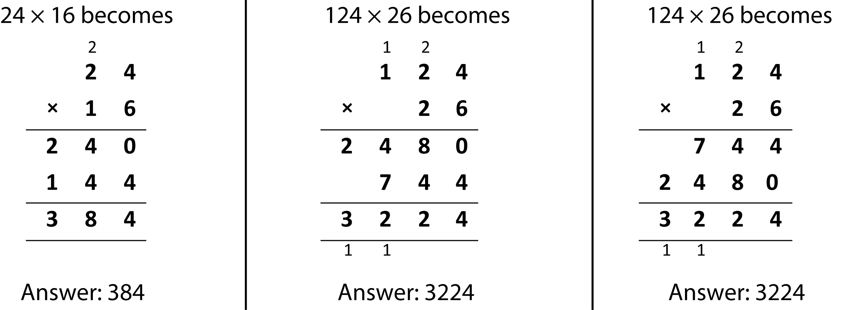
x = signs and missing numbers
Continue using a range of equations as in Year 2 but with appropriate numbers

Partition
47 x 6 = 282

47 x 6 = (40 x 6) + (7 x 6) = 282

OR

Use the grid method of multiplication (as below)

Written methods
Grid method - estimate
72 x 38 is approximately 70 x 40 = 2800
Extend to multiplying 4 digit numbers x 1 digit number.
Extend to simple decimals with one decimal place.

Short multiplication
Extend to Long multiplication when confident with the grid method

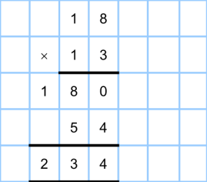

Multiplication
Year 4 Year 5 Year 6
= 7440
= 1488
8928

