Foxes Reading Spine – Cycle
Term: | Autumn 1 | Autumn 2 | Spring 1 | Spring 2 | Summer 1 | Summer 2
Theme: | Linking to topic | Diversity  Links to previous books  (year 2) | Fairy-tale | Classic book  Inclusivity | Links to other texts | Good vs Evil and traditions
Whole Class Reading | 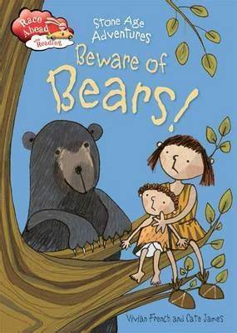 | 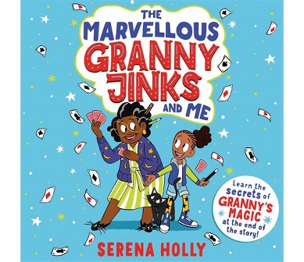 | 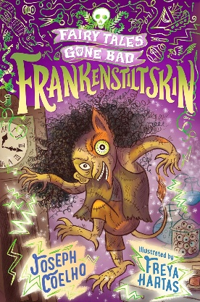  Frankenstiltskin | 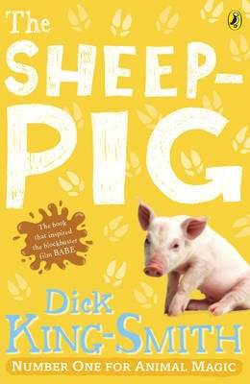 | 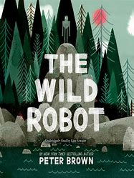 | 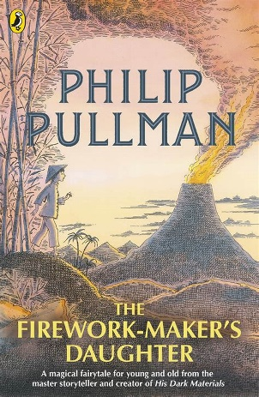
Non-Fiction Coverage | The stone Age- Literacy Shed | Festivals: Literacy shed (year 2)  - Ramadan and Eid - narrative  - Rama and Sita - narrative  - Email from Japan - letter  - A Recipe for Diwali - instructions - Teaching Slides  Bible stories:  - The Lost Sheep  - Jonah and the Whale  - Daniel and the Lion's Den | Healthy Bodies Unit (Literacy Shed Unit)  Post teach for all children- Link to science | Emergency sevices:  - A Day in the Park - narrative text  - The Ambulance Service - information text  - The Fire Service - information text  - Firefighter Fiona - narrative text  - Heroes - poem  - In the Hospital - information text  - The Police - information text  - The RNLI - information text  - What to do in an emergency - information tex | 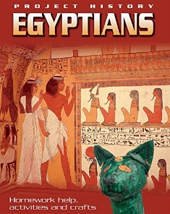  Additional Literacy Shed resources. | Great explorer’s non-fiction pack (year 2/3)
Inspiring texts used in English lessons | Robin Hood  Tunstal (guide)- literacy shed | The Iron Man- Ted Hughes  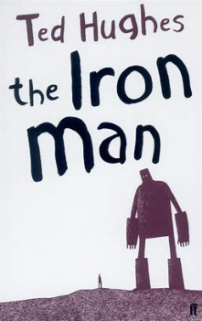 | The Journey- Aaron Becker  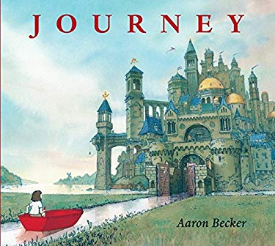 | 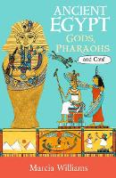  Ancient Egypt, Gods, Pharaohs and Cats | Literacy shed resources  Persuasive adverts. | 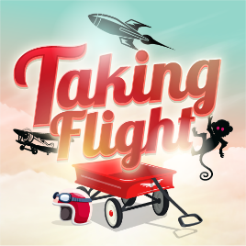  Literacy shed film Unit.

