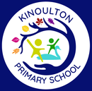 |  |  |  | 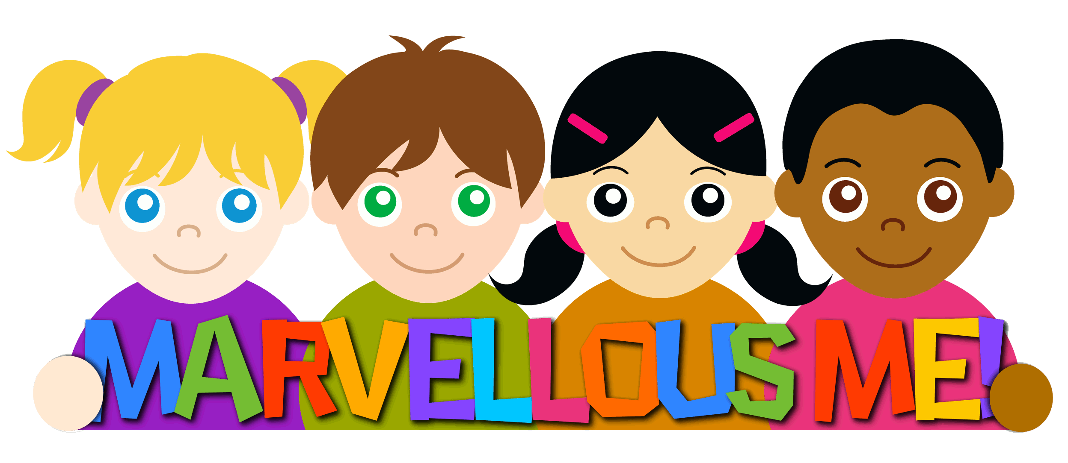 |  | 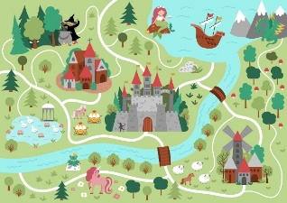 | 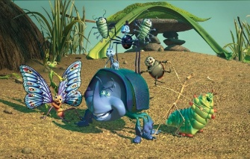 | 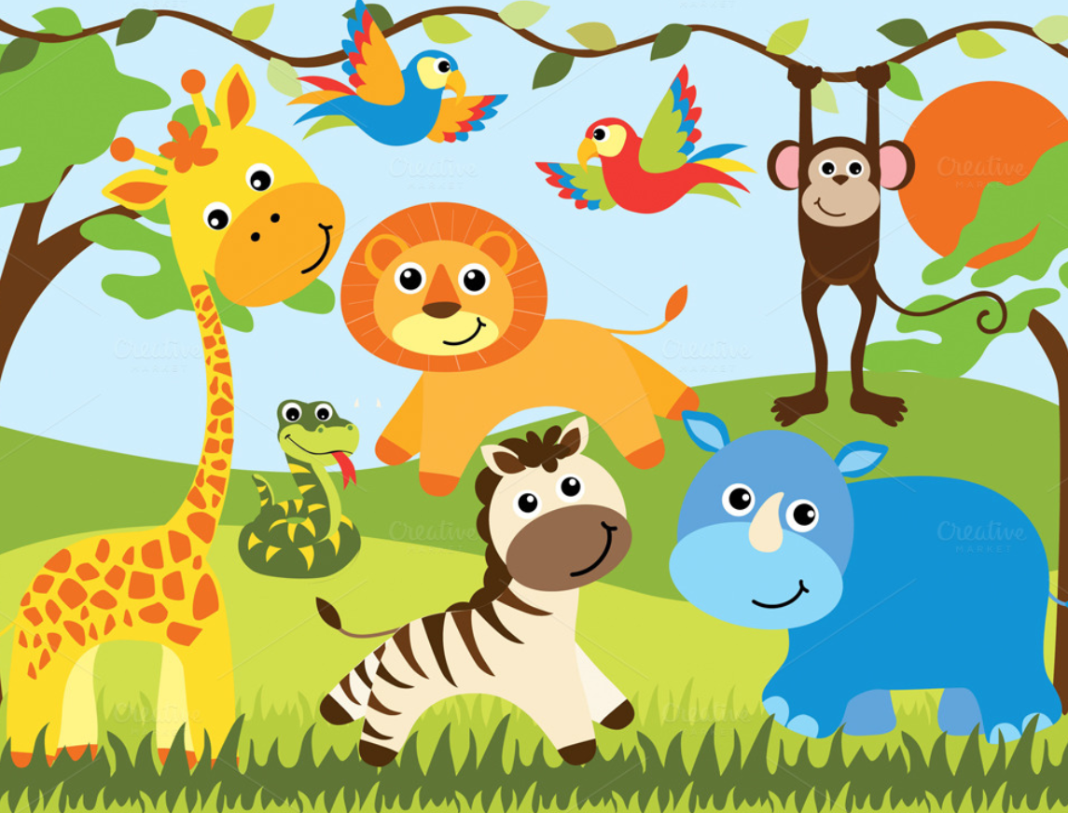 | 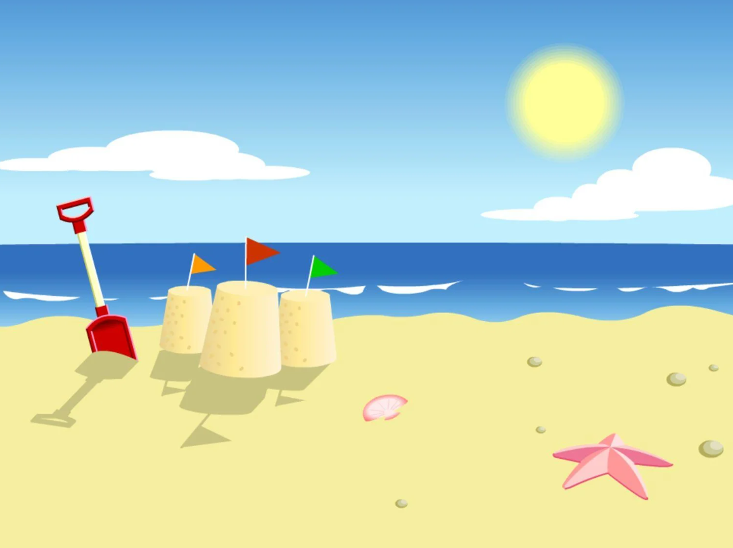
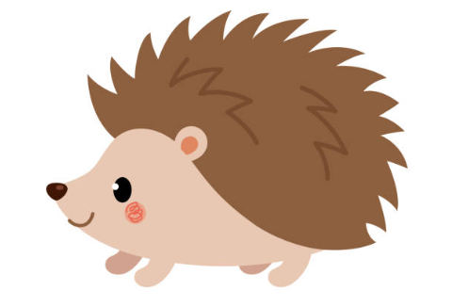 |  |  |  | Marvellous Me | Let’s Celebrate | Once Upon A Time | Down at the bottom of the garden | Amazing Animals | Commotion in the Ocean (and Seasides)
 |  |  |  | Autumn 1 | Autumn 2 | Spring 1 | Spring 2 | Summer 1 | Summer 2
Communication and Language | Nursery (Hoglets) |  | Development Matters (3-4 years) | Listening, Attention and Understanding  Children will point out objects/pictures in a story.  Children will understand ‘what’ questions.  Speaking  Children will know and retell the story ‘Funnybones’.  Children will know and use vocabulary linked to their theme ‘Marvellous Me!’ including family, home, and friends. | Listening, Attention and Understanding  Children will understand ‘who’ questions.  Speaking  Children will know and retell the story ‘Rama and Sita’  Children will know and use vocabulary linked to their theme ‘Let’s Celebrate!’ including celebrate, decoration, Diwali, Christmas. | Listening, Attention and Understanding  Children will understand ‘when’ questions.  Speaking  Children will know and retell the story ‘Goldilocks and the 3 Bears’  Children will know and use vocabulary linked to their theme ‘Once Upon a time. | Listening, Attention and Understanding  Children will understand ‘where’ questions.  Speaking  Children will know and retell the story ‘The Very Hungry Caterpillar’.  Children will know and use vocabulary linked to their theme ‘Down at the bottom of the garden’. | Listening, Attention and Understanding  Children will understand ‘who’ questions.  Speaking  Children will know and retell the story ‘The Tiger who came to tea’  Children will know and use vocabulary linked to their theme ‘Amazing animals’ | Listening, Attention and Understanding  Children will understand and answer ‘why’ questions.  Speaking  Children will know and retell the story ‘The little mermaid’  Children will know and use vocabulary linked to their theme ‘Commotion in the ocean.  Children will be able to talk about their holidays.
 | Observational Checkpoint: Can children shift focus from one task to another if you fully obtain their attention? Can children use sentences of four to six words? Can children join sentences using ‘because’, ‘or’, ‘and’. Can children use future and past tense? Can children answer a simple ‘why’ question?
 | Reception (Hedgehogs) |  | Development Matters (Reception) | Listening, Attention and Understanding  Children will listen carefully to a story.  Children will ask what questions.  Speaking  Children will be know and retell the stories covered in DC.  Children will know and use vocabulary linked to their theme ‘Marvellous Me!’ including special, unique, similar, and different. | Listening, Attention and Understanding  Children will join in with repeated refrains in a story.  Children will ask who questions.  Speaking  Children will be know and retell the stories covered in DC.  Children will know and use vocabulary linked to their theme ‘Let’s Celebrate’ including tradition, Hanukkah, religion. | Listening, Attention and Understanding  Children will talk about key events in a story.  Children will ask when questions.  Speaking  Children will be know and retell the stories covered in DC.  Children will know and use vocabulary linked to their theme ‘Once Upon a time’. See overview sheet for key vocab.  Children will express ideas using past and present tense. | Listening, Attention and Understanding  Children will identify the main characters in the story and talk about their feelings.  Children will ask where questions.  Speaking  Children will be know and retell the stories covered in DC.  Children will know and use vocabulary linked to their theme ‘Down at the bottom of the garden’. See overview sheet for key vocab. | Listening, Attention and Understanding  Children will link events in a story to their own experiences.  Children will ask why questions.  Speaking  Children will be know and retell the stories covered in DC.  Children will know and use vocabulary linked to their theme ‘Amazing Animals’ | Listening, Attention and Understanding  Children will ‘hot seat’ characters from a story.  Children will engage in Non-fiction books.  Speaking  Children will be know and retell the stories covered in DC.  Children will know and use vocabulary linked to their theme ‘Commotion in the Ocean!’ including fossils, marine life, Punch and Judy.  Children will express ideas using past and present tense.
Listening, Attention and Understanding: Listen attentively and respond to what they hear with relevant questions, comments and actions when being read to and during whole class discussions and small group interactions. Make comments about what they have heard and ask questions to clarify their understanding. Hold conversation when engaged in back-and-forth exchanges with their teacher and peers.
Speaking: Participate in small group, class and one-to-one discussions, offering their own ideas, using recently introduced vocabulary. Offer explanations for why things might happen, making use of recently introduced vocabulary from stories, non-fiction, rhymes and poems when appropriate. Express their ideas and feelings about their experiences using full sentences, including use of past, present and future tenses and making use of conjunctions, with modelling and support from their teacher.
Personal, Social and Emotional | Nursery | Development Matters (3-4 years) |  | Self-Regulation  Children will separate from main carer to come into the classroom.  Managing Self  Children will know the class rules:  - Looking eyes  - Listening ears  - Hands in lap  Children will know to wash and dry their hands before eating and after using the toilet.  Building Relationships  Children will know how to play alongside each other. | Self-Regulation  Children will know what adults can help them in Hedgehogs.  Managing Self  Children will know how to look after resources using the rhyme ‘Choose it, use it, put it away’.  Children will respond to the tidy up song.  Children will know to drink water to be healthy.  Building Relationships  Children will know how to play partner games. | Self-Regulation  Children will become confident with visitors in the classroom and school.  Managing Self  Children will know examples of healthy food.  Building Relationships  Children will share resources and play in a group. | Self-Regulation  Children will show confidence and become more outgoing in the safe context of the setting.  Managing Self  Children will know to exercise to be healthy.  Building Relationships  Children will take turns whilst playing and waiting patiently to have a go. | Self-Regulation  Children will show confidence in visiting the local church.  Managing Self  Children will know to brush their teeth to be healthy.  Building Relationships  Children will consider the feelings of others in stories such as Lucy’s Blue Day. | Self-Regulation  Children will show confidence walking around our local area.  Managing Self  Children will know how to calm themselves by stopping and taking deep breaths.  .  Building Relationships  Children will know how to listen to a friend and agree a compromise.
 | Observational Checkpoint: Can children share and take turns with others, with adult guidance and understanding ‘yours’ and ‘mine’? Can children settle at activities for a while? Can children play alongside others? Can children take part in pretend play, taking on a role such as Mummy or Daddy? Can children take part in pretend play with different roles such as the Gruffalo? Can children negotiate solutions to conflicts in their play?
 | Reception | Development Matters (Reception) |  | Self-Regulation  Children will see themselves as unique by sharing their hobbies and interests.  Managing Self  Children will know the school rules.  Children will know how regular exercise is important for their health.  Building Relationships  Children will know how to identify their feelings, using books such as ‘The Colour Monster’ to support understanding. | Self-Regulation  Children will know how to be helpful by taking on jobs such as serving snack and washing up.  Managing Self  Children will know how to be a safe pedestrian and why this is important.  Building Relationships  Children will know how to listen to others with respect. | Self-Regulation  Children will know how to make the right choice and the consequences of not doing so.  Managing Self  Children will know about the importance of a good sleep routine for their health.  Building Relationships  Children will know how to treat others in our class using the statement ‘Kind hands and kind words’. | Self-Regulation  Children will know the effects of their behaviour on others.  Managing Self  Children will know how healthy eating is important for their health.  Building Relationships  Children will be able to describe what makes a good friend including attributes such as listening and sharing. | Self-Regulation  Children will know to use the calm corner when they are feeling upset/angry.  Managing Self  Children will know how regular teeth brushing is important for their health  Building Relationships  Children will know how to express their opinion and understand it is okay to have a different opinion to their friends. | Self-Regulation  Children will know how to overcome challenges, using books such as  ‘Shine’  Managing Self  Children will know what a sensible amount of screen time is and why this is important for their health.  Building Relationships  Children will know how to resolve a problem by talking it through with a friend or adult.
Self-Regulation: Show an understanding of their own feelings and those of others, and begin to regulate their behaviour accordingly. Set and work towards simple goals, being able to wait for what they want and control their immediate impulses when appropriate. Give focused attention to what the teacher says, responding appropriately even when engaged in activity, and show an ability.
Managing Self: Be confident to try new activities and show independence, resilience and perseverance in the face of challenge. Explain the reasons for rules, know right from wrong and try to behave accordingly. Manage their own basic hygiene and personal needs, including dressing, going to the toilet and understanding the importance of healthy food choices.
Building Relationships: Work and play cooperatively and take turns with others. Form positive attachments to adults and friendships with peers. Show sensitivity to their own and to others’ needs.

Physical | Nursery | Development Matters (3-4 years) | Gross Motor  Children will know how to ride a scooter.  Fine Motor  Children will explore large mark making to develop cross the mid-line movements. | Gross Motor  Children will know how to ride a tricycle.  Fine Motor  Children will know how to zip up their coat. | Gross Motor  Children will know how to throw a ball.  Fine Motor  Children will know how to use hammers to hit a large headed nail. | Gross Motor  Children will know how to climb using alternate feet.  Fine Motor  Children will know how to use loop scissors to make snips in paper. | Gross Motor  Children will know how to skip, hop and stand on one leg.  Fine Motor  Children will know how to use a comfortable grip when holding a pencil. | Gross Motor  Children will know how to work together to carry large items such as planks of wood.  Fine Motor  Children will show preference for a dominant hand.
 | Observational Checkpoint: Can children make ‘cross the mid-line’ marks on vertical surfaces? Can children move in a range of ways including hopping, climbing and balancing? Can children work in groups/teams? Can children use one-handed tools such as scissors or a hammer? Do children have a comfortable grip when using pens/pencils? Are children independent in dressing themselves?
 | Reception | Development Matters (Reception) | Gross Motor  Children will know how to hop, skip and jump.  Fine Motor  Children will know the correct pencil grip and posture for writing. | Gross Motor  Children will know how to ride a balance bike.  Fine Motor  Children will know how to do up and undo buttons. | Gross Motor  Children will know how to pull themselves up rope and hang on monkey bars.  Fine Motor  Children will know how to use a knife and fork. | Gross Motor  Children will know how to kick and pass different sized balls.  Fine Motor  Children will know how to use two-hole scissors to make snips in paper. | Gross Motor  Children will know how to throw and catch different sized balls.  Fine Motor  Children will know how to use two-hole scissors to cut along lines. | Gross Motor  Children will know how to bat and aim using different sized balls.  Fine Motor  Children will know how to thread and sew
Gross Motor: Negotiate space and obstacles safely, with consideration for themselves and others. -Demonstrate strength, balance and coordination when playing. -Move energetically, such as running, jumping, dancing, hopping, skipping and climbing.
Fine Motor: Hold a pencil effectively in preparation for fluent writing – using the tripod grip in almost all cases; - Use a range of small tools, including scissors, paint brushes and cutlery; - Begin to show accuracy and care when drawing.

Literacy |  | Nursery |  | Development Matters (3-4 years) |  | Comprehension  Children will know the logos for local supermarkets.  Children will read and re-read a selection of books to engage in conversations about the story, develop understanding and learn new vocabulary.  Word Reading  Children will spot and suggest rhymes.  Writing  Children will know how to draw horizontal lines. | Comprehension  Children will know a range of signs including bus stop, parking, stop.  Children will read and re-read a selection of books to engage in conversations about the story, develop understanding and learn new vocabulary.  Word Reading  Children will clap syllables in a word.  Writing  Children will know how to draw vertical lines. | Comprehension  Children will know print has different purposes by exploring menus, magazines, newspapers, labels.  Children will read and re-read a selection of books to engage in conversations about the story, develop understanding and learn new vocabulary.  Word Reading  Children will know familiar words with the same initial sound such as mum and milk.  Writing  Children will know how to draw circles. | Comprehension  Children will know the names of different parts of a book including the cover, title, author.  Children will read and re-read a selection of books to engage in conversations about the story, develop understanding and learn new vocabulary.  Word Reading  Writing  Children will know how to draw diagonal lines. | Comprehension  Children will know how to turn the pages of a book carefully.  Children will read and re-read a selection of books to engage in conversations about the story, develop understanding and learn new vocabulary.  Word Reading  Writing  Children will write the initial sound in their name. |  | Comprehension  Children will know how to read from left to right and top to bottom.  Children will read and re-read a selection of books to engage in conversations about the story, develop understanding and learn new vocabulary.  Word Reading  Writing  Children will write their name.
 |  | Observational Checkpoint: Can children identify a range of different signs? Do children know how to handle a book and turn the pages one at a time? Can children identify rhymes and clap syllables? Can children talk to an adult about a story that they have enjoyed? Can children write their name?
 |  | Reception |  | Development Matters (Reception) |  | Comprehension  Children will read and re-read a selection of books, developing VIPERS skills, fluency, understanding and enjoyment.  Word Reading  Children will read and correctly form the sounds  s,a,t,p,I,n,m,d,g,o,c,k,ck,e,u,r,h,b  Children will hear and identify initial sounds in words.  Writing  See MP handwriting scheme.  Children will know how to write their name. | Comprehension  Children will read and re-read a selection of books, developing VIPERS skills, fluency, understanding and enjoyment.  Word Reading  Children will read and correctly form the sounds f, ff, l, ll, ss,j,v,  w,x,y,z,zz,qu,ch,sh,yh,ng,oo,ar  Children will blend known sounds in words.  Writing  See MP handwriting scheme.  Children will know how to write initial sounds. | Comprehension  Children will read and re-read a selection of books, developing VIPERS skills, fluency, understanding and enjoyment.  Word Reading  Children will read and correctly form the sounds oo,ow,ee,ur,ai,or  Children will blend known sounds in words.  Writing  See MP handwriting scheme.  Children will know how to write CVC/CVCC words. | Comprehension  Children will read and re-read a selection of books, developing VIPERS skills, fluency, understanding and enjoyment.  Word Reading  Children will read and correctly form the sounds oa,er,igh,air,oi,ure,ear  Children will blend known sounds in words.  Writing  See MP handwriting scheme.  Children will know how to write a short phrase or sentence. |  | Comprehension  Children will read and re-read a selection of books, developing VIPERS skills, fluency, understanding and enjoyment.  Word Reading  Children will sound out and blend: cvcc, ccvc, cvc+,ccvcc  (including previously taught digraphs)  Children will blend known sounds in words.  Writing  See MP handwriting scheme.  Children will know how to write a short sentence. | Comprehension  Children will read and re-read a selection of books, developing VIPERS skills, fluency, understanding and enjoyment.  Word Reading  Children will sound and blend:  Cvc+ polysyllabic, CCC onset words, CCVCC, CVC+ HFW  Writing  See MP handwriting scheme.  Children will know how to read what they have written to check it makes sense.
Comprehension: Demonstrate understanding of what has been read to them by retelling stories and narratives using their own words and recently introduced vocabulary. Anticipate (where appropriate) key events in stories. Use and understand recently introduced vocabulary during discussions about stories, non-fiction, rhymes and poems and during role play.
Word Reading: Say a sound for each letter in the alphabet and at least 10 digraphs. Read words consistent with their phonic knowledge by sound-blending. Read aloud simple sentences and books that are consistent with their phonic knowledge, including some common exception words.
Writing: Write recognisable letters, most of which are correctly formed. Spell words by identifying sounds in them and representing the sounds with a letter or letters. Write simple phrases and sentences that can be read by others.
Maths | Nursery |  | Development Matters (3-4 years) |  | Number  Children will rote count to 5.  Numerical Patterns  Children will sort by colour, size and object.  Children will sequence events using language including first, then and after.  Children will identify patterns around them such as stripes on clothes. |  | Number  Children will count to in correspondence to 5.  Numerical Patterns  Children will compare big and small.  Children will identify a circle, square and triangle.  Children will use language including sides, corners, straight, flat and round. | Number  Children will count in correspondence to 5, knowing that the total is 5.  Children will show ‘finger numbers’ up to 5.  Numerical Patterns  Children will use language including tall, long, short.  Children will identify a cube. | Number  Children will rote count to 10.  Children will identify more/less.  Numerical Patterns  Children will use positional language including on top, under, next to and behind.  Children will match objects that are the same. | Number  Children will count in correspondence to 10.  Children will subitise to 3.  Numerical Patterns  Children will use language including light, heavy, full and empty.  Children will make shape pictures using a tangram.  Children will solve real world mathematical problems with numbers up to 5. |  | Number  Children will count recognise numbers 1, 2 and 3.  Numerical Patterns  Children will make an AB repeating pattern.  Children will notice and correct an error in a repeating pattern.  Children will discuss routes and locations using words such as ‘in front of’ and ‘behind’.
 | Observational Checkpoint: Can children subitise to 3? Can children count in correspondence to 5? Can children rote count beyond 5? Can children compare quantities, size, length, weight and capacity? Can children talk about 2D and 3D shapes? Can children use positional language? Can children select shapes appropriately? Can children create a repeating pattern?
 | Reception |  | Development Matters (Reception) |  | Number  Children will represent, compose and compare numbers to 3.  Numerical Patterns  Children will match and sort.  Children will compare amounts, size, mass and capacity.  Children will make patterns. |  | Number  Children will represent, compose and compare numbers to 5.  Numerical Patterns  Children will identify and describe circles, triangles, squares and rectangles.  Children will use positional language including under, over, around and through.  Children will identify one more and one less within 5. | Number  Children will know number bonds to 4.  Children will identify 0.  Children will represent, compose and compare numbers to 8.  Numerical Patterns  Children will compare mass and capacity.  Children will make pairs. | Number  Children will know number bonds to 5.  Numerical Patterns  Children will combine 2 groups.  Children will explore length, height and time.  Children will compare numbers to 10.  Children will identify a cube, sphere, cylinder and cone.  Children will make ABB/AAB repeated patterns. | Number  Children will know 5+5=10, 0+10+10.  Children will count forwards and backwards within 10.  Numerical Patterns  Children will build and identify numbers to 20.  Children will match patterns using tangrams and shapes.  Children will add more and take away within 20. |  | Number  Children will double within 10.  Numerical Patterns  Children will equally share into two groups.  Children will identify even and odd numbers up to 10.  Children will verbally count beyond 20.
Number: Have a deep understanding of number to 10, including the composition of each number. Subitise (recognise quantities without counting) up to 5. Automatically recall (without reference to rhymes, counting or other aids) number bonds up to 5 (including subtraction facts) and some number bonds to 10, including double facts.
Numerical Patterns: Verbally count beyond 20, recognising the pattern of the counting system. Compare quantities up to 10 in different contexts, recognising when one quantity is greater than, less than or the same as the other quantity. Explore and represent patterns within numbers up to 10, including evens and odds, double facts and how quantities can be distributed equally.

Understanding the World | Nursery - Development Matters (3-4 years)? | History | Past and Present  Children will know they were a baby.  *Talk about how they have changed since they were a baby. | Past and Present  Children will know about Poppy Day and Bonfire Night. | Past and Present  Children find out about Chinese New Year.  The Year of the Snake. | Past and Present  Children will find out about Spring and know before it was Winter and next it will be Summer, then Autumn. | Past and Present  Children will find out about St. George’s day and how we celebrate. | Past and Present  *Know about some famous pirates from the past.  *Talk about their holidays to the seaside.
 |  | Geography | People, Culture and Communities  Children will learn from visitors of various occupations inc. a plumber, farmer, vet.  Children will talk about differences and similarities between themselves and people in their local community. | People, Culture and Communities  Children will know that a globe represents the world.  *Sing songs about the continents and space.  *Know that some places are hot and some are cold. | People, Culture and Communities  Children will know the name of the village that our school is in.  Children will know that China is in a different part of the world. | People, Culture and Communities | People, Culture and Communities  Children will find out about the England flag. | People, Culture and Communities  *Name an ocean.  *Begin to understand what recycling is.  *Talk about how to keep the world clean
 |  | Science | *Know the names of body parts (head, arms, hands, legs, feet, neck)  *Name the 5 senses  *Talk about and observe how the seasons change. | The Natural World  *Investigate light and dark | *Talk about and explore forces including floating and sinking.  *Talk about and observe how the seasons change. | The Natural World  Know that a butterfly comes from an egg.  *Know that seeds can turn into plants.  *Begin to understand how it takes time to grow fruit and veg.  *Be able to plant and grow fruit/vegetable/  herb.  *Talk about and observe how the seasons change | The Natural World  *Make collections of natural materials to investigate and talk about.  *Know how to respect and care for living things.  *Know how materials change when heating, cooling and melting | The Natural World  *Talk about and explore forces and magnets.  *Talk about and observe how the seasons change.
 |  | RE | People, Culture and Communities  Children will know how and why we celebrate Harvest Festival. | People, Culture and Communities  Children will know that some people celebrate Diwali.  Children will know that some people celebrate Christmas. | People, Culture and Communities  Children will listen to different stories from the bible. | People, Culture and Communities  Children will find out about Palm Sunday.  Children will know some people celebrate Easter. | People, Culture and Communities  Children will listen to a selection of bible stories.  Book-Stories Jesus Told by Nick Butterworth. | People, Culture and Communities  Children will take time to reflect and say a short thank you prayer.
 |  | Computing | Children will know how to use a camera to take photos. | Children will know how to use the Interactive white board. | Children will know how to select an app on an iPad. | Children will know how to make digital art on the iPad/IWB. | Children will know how to play interactive games on the iPad/IWB. | Children will learn how to operate wind-up toys and pulleys.
 | Observational Checkpoint: Can children use their senses to explore? Can children make sense of their own life-story and family history? Can children understand the key features of the life cycle of a plant and an animal? Do children show an interest in different occupations? Can children talk about differences between materials and changes they notice? Can children talk about different countries in the world?

Understanding the World | Reception - Development Matters (Reception) | History | Past and Present  Children will know how they have changed from being a baby to being 4/5.  Children will know who Florence Nightingale is and why she is important. | Past and Present  Children will explore images, stories and artefacts from the past.  Know who Guy Fawkes was and explain the main events of the Gunpowder Plot.  Children will know that Remembrance Day is to remember soldiers who died in the war. | Past and Present  Children will retell the story of Chinese New Year. | Past and Present | Past and Present  Children will know who David Attenborough is and why he is important.  Children will know that the past is anything before the current day.  Children will now that the present is now. | Past and Present  Children will know who Mary Anning is and why she is important.  Children will look at images of seaside holidays from the past and present and identify similarities and differences.
 |  | Geography | People, Culture and Communities  Children will identify typical weather in Autumn.  Children will talk about where they live. | People, Culture and Communities  *Know that the green on the globe is land and the blue is sea.  *Know that the globe shows different countries around the world.  *Know how people in different countries celebrate Christmas.  *Know the names of the polar regions and be able to explain why it is cold there. | People, Culture and Communities  Children will know where China is on a map and say what the capital is called.  Children will talk about how life in China might be similar/different to here. | People, Culture and Communities  Children will know the name of the road our school is on.  Spend time looking at aerial maps of our school and Kinoulton and identify key features.  Begin to understand the terms physical and human features.  Children will name some of the plants and trees that grow in our school grounds.  Children will identify typical weather in Spring. | People, Culture and Communities  Children will know that we do not have certain animals in England. | People, Culture and Communities  *Name some seaside holiday locations.  *Talk about the features of the seaside.  *Name the worlds oceans.  *Identify typical weather in Summer.
 |  | Science | The Natural World  Children will know the names of body parts: shoulders, elbows, knees, ankles.  Children will know the 5 senses.  Children will know that this time of year is Autumn. | The Natural World  Children will explore shadows.  Children will look at a variety of different light sources.  Children will understand what the term nocturnal means and name some nocturnal animals.  Children will know that there are 8 planets in the solar system. | The Natural World  Children will know that this time of year is Winter.  Children will explore floating and sinking.  Children will make simple predictions. | The Natural World  Children will observe the growth and changes of caterpillars to butterflies.  Children will confidently know the life cycle of a butterfly.  Children will know that this time of year is called Spring and identify the signs of Spring.  Children will know how to care for a plant.  Children will know the lifecycle of a sunflower. | The Natural World  Children will explore melting and solidifying different materials such as chocolate and butter.  Children will identify and describe a variety of different materials.  Children will make simple predictions and reflections.  Children will complete a whole class investigation.  Children will be able to sort animals into simple groups. | The Natural World  Children will know that some animals can live underwater.  Children will know that this time of year is called Summer and identify the signs of Summer.  Children will know the names of the 4 seasons and the weather associated with each season.  Children will observe how a tree has changed over the 4 seasons.  Children will know what material a magnet will pick up
 |  | RE | People, Culture and Communities  Children will know what is special to them and their families. | People, Culture and Communities  Children will know the story of Diwali.  Children will know the Christian Christmas story. | People, Culture and Communities  Children will know a selection of stories from the bible. | People, Culture and Communities  Children will be able to explain what a miracle is. | People, Culture and Communities  Children will name and explain the purpose of a church. | People, Culture and Communities  Children will be able to retell some stories from the New Testament.
 |  |  | Children will know how to use an iPad to take photos. | Children will know how to use keys on a keyboard to type their name. | Children will know how to use a trackpad to move a cursor. | Children will know how to use the laptop to make digital art using the programme ‘paint’. | Children will know how to programme a beebot. | Children will know how to ask google a question using dictation.
Past and Present: Talk about the lives of the people around them and their roles in society. Know some similarities and differences between things in the past and now, drawing on their experiences and what has been read in class. Understand the past through settings, characters and events encountered in books read in class and storytelling.
People, Culture and Communities: Describe their immediate environment using knowledge from observation, discussion, stories, non-fiction texts and maps. Know some similarities and differences between different religious and cultural communities in this country, drawing on their experiences and what has been read in class. Explain some similarities and differences between life in this country and life in other countries, drawing on knowledge from stories, nonfiction texts and (when appropriate) maps.
The Natural World: Explore the natural world around them, making observations and drawing pictures of animals and plants. Know some similarities and differences between the natural world around them and contrasting environments, drawing on their experiences and what has been read in class. Understand some important processes and changes in the natural world around them, including the seasons and changing states of matter.

Expressive Arts and Design | Nursery - Development Matters (3-4 years) | Music
 |  | Art and Design | Creating with Materials  Children will do large scale drawings/paintings.  Children will use pencils to free draw. | Creating with Materials  Children will paint on a flat surface and an easel.  Children will explore and recreate art in the style of Jackson Pollock. | Creating with Materials Children will explore colour mixing.  Children will use pencils to draw closed shapes such as squares and rectangles. | Creating with Materials Children will explore painting with a range of tools such as cotton buds, vegetables, toothbrushes etc.  Children will explore and make art in the style of Piet Mondrian. | Creating with Materials Children will explore painting on a range of different surfaces such as tin foil, cling film, sugar paper etc.  Children will do observational drawings. | Creating with Materials Children will explore various painting techniques such as splatter painting, bubble painting, straw painting, printing etc.  Children will explore and make art in the style of Andy Goldsworthy.
 | Observational Checkpoint: Can children take part in pretend play? Can children create using different materials? Can children develop their own creative ideas by drawing and painting? Can children perform a range of songs? Can children play instruments to express their own ideas?
 | Reception - Development Matters (Reception) | Music
 |  | Art and Design | Creating with Materials Children will know how to mix primary colours to make secondary colours using poster paints.  Children will know how to draw a person – head, body, arms, legs and facial features.  Children will know how to make the flange join and treasury tag join. | Creating with Materials Children will know how to print using objects and paint. | Creating with Materials Children will know how to make 2D collages.  Children will explore and make art in the style of Henry Matisse.  Children will know how to make an l-brace join. | Creating with Materials Children will know how to use and mix watercolour paints.  Children will know how to use different techniques to make 3D collages.  Children will know how to make a slot join. | Creating with Materials Children will know how to make a mono print.  Children explore and create art in the style of Henri Rousseau.  Children will know how to make a tab join. | Creating with Materials Children will know how to make different shades of the same colour.  Children explore and create art in the style of LS Lowry  Children will know how to make a split pin join.  Children will know how to sew to join.
Creating with Materials: Safely use and explore a variety of materials, tools and techniques, experimenting with colour, design, texture, form and function. Share their creations, explaining the process they have used. Make use of props and materials when role playing characters in narratives and stories.
Being Imaginative: Invent, adapt and recount narratives and stories with peers and their teacher. Sing a range of well-known nursery rhymes and song. Perform songs, rhymes, poems and stories with others, and (when appropriate) try to move in time with music

