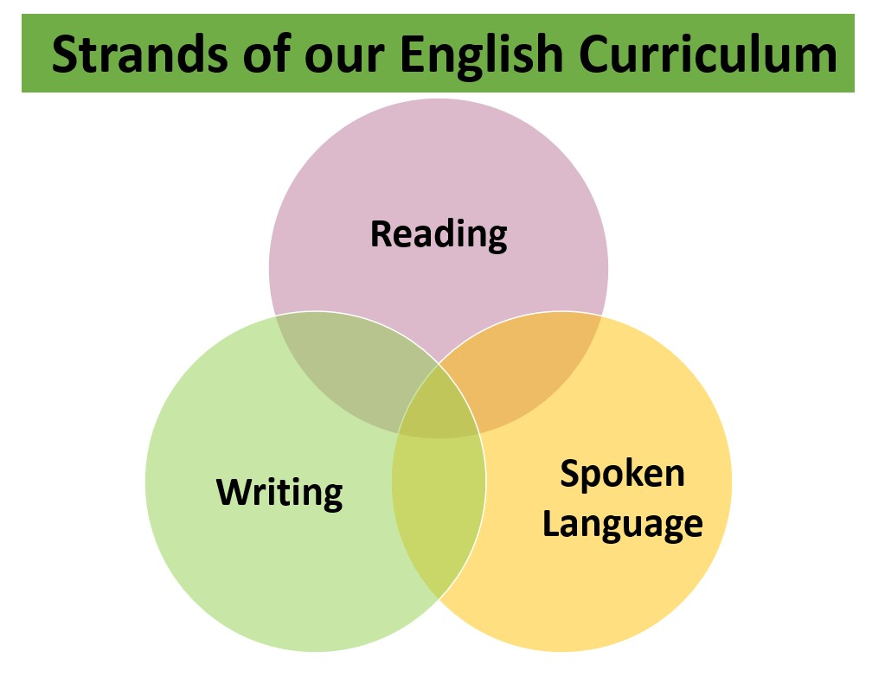

|  |  |  |  |  |  |
| --- | --- | --- | --- | --- | --- |
| **Reading** | | | | | |
| **Word Reading** | | | | **Language Comprehension** | |
| **Decoding** | **Full Word Recognition** | | **Fluency:**  *Accuracy Automaticity Prosody* | **Inference**  **Retrieval**  **Predict**  **Explain**  **Summarise**  **Sequence** | **Text Structure** |
| **Phonological Knowledge**  *(see separate Monster Phonics information)* | | **Print Knowledge** | | **Grammar and syntax** | **Vocabulary** |

|  |  |  |
| --- | --- | --- |
|  | **Writing** |  |
| **Transcription** | **Composition** | **SP&G** |
| **Spelling**  **Handwriting** | **Evaluate models**  **Plan**  **Draft**  **Evaluate**  **Edit & Improve Publish\*** | **Spelling**  **Punctuation Grammar** |

|  |  |  |
| --- | --- | --- |
| **S** | **poken Language** | |
| **Listening and attention** | **Audibility, prosody and fluency** | **Structure, formality and grammar** |