+ = signs, missing numbers and number bonds

Children need to understand the concept of equality before using the ‘=’ sign. Calculations should be written either side of the equality sign so that the sign is not just interpreted as ‘the answer’.

2 = 1+ 1
2 + 3 = 4 + 1
3 = 3
2 + 2 + 2 = 4 + 2
Missing numbers need to be placed in all possible places.

3 + 4 = = 3 + 4
3 + = 7 7 = + 4
+ 4 = 7 7 = 3 +
+ ∇ = 7 7 = + ∇
Number bonds
Chilsren will begin to explore different ways of making numbers using concrete materials and diagrams.
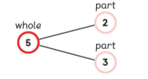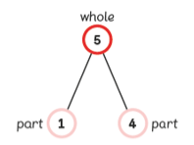
Activities
Children should have access to a wide range of counting equipment, everyday objects, as well as hoops, sorting trays, number tracks, ten frames and numbered number lines.

Teacher modelling
Drawing jumps on numbered number lines to support understanding of the mental method and pictorial representations.
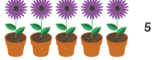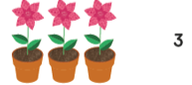
Children
To create their own jumps using rulers, fingers, pens, bodies etc.
7+ 4

+ = signs and missing numbers
Continue using a range of equations as in Year 1 and 2 but with appropriate, larger numbers.
Partition into tens, ones and hundreds
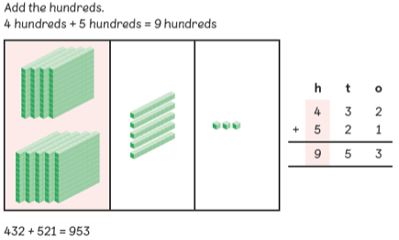
Children need to be secure adding multiples of 100 and 10 to any three-digit number including those that are not multiples of 10.

Add a near multiple of 10 to a two-digit number
Secure mental methods by using a number line. Continue as in Year 2 but with appropriate numbers
e.g. 35 + 19 is the same as 35 + 20 – 1.
Children need to be secure adding multiples of 10 to any two-digit number including those that are not multiples of 10. 48 + 36 = 84
Use models to solve problems
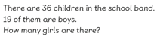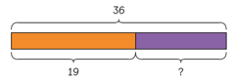
pencil and paper procedures - 278 + 349 = 627
Children use a formal columnar algorithm, initially introduced alongside the expanded method. The formal method should be seen as a more streamlined version of the expanded method, not a new method. Adding with and without renaming.
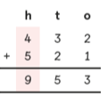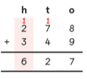
+ = signs and missing numbers
Continue using a range of equations as in Year 1 but with appropriate, larger numbers.
Extend to
14 + 5 = 10 + and 32 + + = 100 35 = 1 + + 5
Partition into tens and ones and recombine
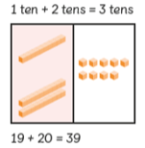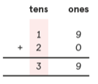

Count on in tens and ones
23 + 12 = 23 + 10 + 2
= 33 + 2
= 35
Partitioning and bridging through 10.
The steps in addition often bridge through a multiple of 10
e.g.Children should be able to partition the 7 to relate adding the 2 and then the 5.
8 + 7 = 15

Add 9 or 11 by adding 10 and adjusting by 1

e.g.

Add 9 by adding 10 and adjusting by 1
35 + 9 = 44 +10
-1
1. Vertical expansion 2. Horizontal expansion
83 80 + 3
+ _42 + 40 + 2
5 120 + 5 = 125
120
125

Addition
Year 1 Year 2 Year 3

+2
+5

