**+ = signs and missing numbers**

Continue using a range of equations as in Year 1, 2and 3 but with appropriate numbers.

# Partition into hundreds, tens, ones and decimal fractions and recombine

Either partition both numbers and recombine or partition the second number only e.g.

35.8 + 7.3 = 35.8 + 7 + 0.3

= 42.8 + 0.3

= 43.1

**Add the nearest multiple of 10, 100 or 1000, then adjust**

Continue as in Year 2, 3, 4 and 5 but with appropriate numbers including extending to adding 0.9, 1.9, 2.9 etc

**Pencil and paper procedures**

Extend to numbers with any number of digits and decimals with 1, 2 and/or 3 decimal places.

13.86 + 9.481 = 23.341

13.86

+ 9.481

23.341

1 1 1

Revert to expanded methods if the children experience any difficulty.

**+ = signs and missing numbers**

Continue using a range of equations as in Year 1, 2 and 3 but with appropriate numbers.

# Partition into hundreds, tens and ones and recombine

Partition all the numbers and recombine.

Find the sum of 16603 and 17245

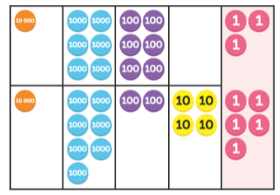 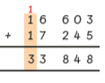

20000 + 1300 + 800 + 40 + 8

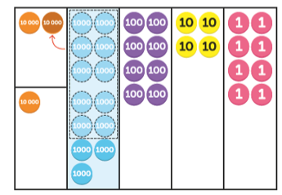

**Add or subtract the nearest multiple of 10 or 100, then adjust**

Continue as in Year 2, 3 and 4 but with appropriate numbers e.g. 458 + 79 = is the same as 458 + 80 - 1

**Pencil and paper procedures**

Extend to numbers with at least four digits, progressing to more than four digits.

13587 + 2675 = 4262

13587

+ 675

14262

1 1 1

Revert to expanded methods if the children experience any difficulty.

Extend to up to two places of decimals (same number of decimals places) and adding several numbers (with different numbers of digits).

72.83

+54.64

127.47

1 1

**+ = signs and missing numbers**

Continue using a range of equations as in Year 1, 2 and 3 but with appropriate numbers.

# Partition into tens and ones and recombine

Partition all the numbers and recombine.

Find the sum of 2314 and 4240

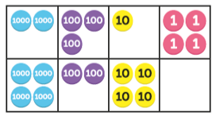 

600 + 50 +50 + 4

**Add the nearest multiple of 10, then adjust**

# Continue as in Year 2 and 3 but with appropriate numbers e.g. 63 + 29 is the same as 63 + 30 - 1

# Pencil and paper procedures

Extend to numbers with at least four digits.

3635

+ 4517

8152

1 1

Children should be able to make the choice of reverting to expanded methods if experiencing any difficulty.

Extend to up to two places of decimals (same number of decimals places) and adding several numbers (with different numbers of digits).

73.8

+ 64.6

138.4

1 1

Extend to decimals in the context of money.

# Addition

**Year 4 Year 5 Year 6**