Multiplication is related to doubling and counting groups of the same size.

Looking at columns Looking at rows
2 + 2 + 2 3 + 3
3 groups of 2 2 groups of 3

Counting using a variety of practical resources
Counting in 2s e.g. counting socks, shoes, animal’s legs…
Counting in 5s e.g. counting fingers, fingers in gloves, toes…
Counting in 10s e.g. fingers, toes…

Pictures / marks

There are 3 sweets in one bag.
How many sweets are there in 5 bags?

Arrays and repeated addition
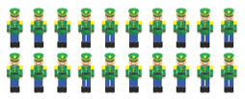
There are 10 toy soldiers in 1 row. How many is 2 rows?

-    4 x 2 or 4 + 4
-   
2 x 4 or 2 + 2 + 2 + 2

x = signs and missing numbers
Continue using a range of equations as in Year 2 but with appropriate numbers.

Arrays and repeated addition
Continue to understand multiplication as repeated addition and continue to use arrays (as in Year 2).
4 x10 = 40

10 x 4 = 40

Doubling multiples of 5 up to 50
35 x 2 = 70

Partition 30 5
x2 = 60 x2 = 10 60 + 10 = 70

Introduce short method

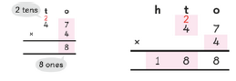

x = signs and missing numbers
7 x 2 =   = 2 x 7
7 x  = 14 14 =  x 7
 x 2 = 14 14 = 2 x 
 x ∇ = 14 14 =  x ∇

Arrays and repeated addition see Year 1
Include multiplications not in the 2,3,5 or 10 times tables

Use bar models to represent a problem. e.g Elliot bought 5 bags of rice. Each bag had a mass of 3kg how many kg dd he buy?
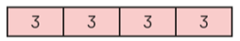4 x 3 =12kg
Begin to develop understanding of multiplication as
scaling (3 times bigger / taller)
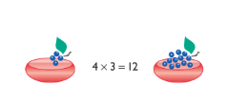

Doubling multiples of 5 up to 50
15 x 2 = 30

Partition
Children need to be secure with partitioning numbers into 10s and 1s and partitioning in different ways: 6 = 5 + 1 so
e.g. Double 6 is the same as double five add double one.
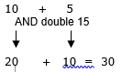

Multiplication
Year 1 Year 2 Year 3

