÷ = signs and missing numbers
Continue using a range of equations as in Year 2 but with appropriate numbers.

Sharing and grouping
30 ÷ 6 can be modelled as:
grouping – groups of 6 placed on no. line and the number of groups counted e.g.
sharing – sharing among 6, the number given to each person

Pencil and paper procedures

Use short method of division (bus stop)

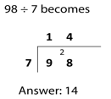

Division with remainders

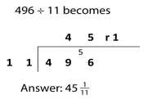

÷ = signs and missing numbers
Continue using a range of equations as in Year 2 but with appropriate numbers.

Sharing and grouping
Continue to understand division as both sharing and grouping (repeated subtraction).

Pencil and paper procedures

Continue with formal methods including long division

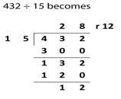
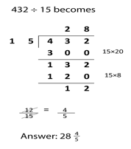

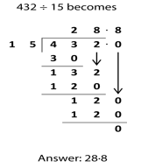
÷ = signs and missing numbers
Continue using a range of equations as in Year 2 but with appropriate numbers.

Sharing and grouping
Continue to understand division as both sharing and grouping (repeated subtraction).

Pencil and paper procedures

Use short method of division with and without remainders

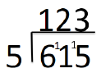

Introduce long division with and without remainders
Answer 28 remainder 12

Division
Year 4 Year 5 Year 6

